⚕️ Project Sanctum- Instructions Guide

Project Sanctum- Instructions Guide
(New Writer Version)

Welcome!
You are joining a team of clinicians who guard the clinical simulations that frontier AI models are tested against.
You build the Worlds and design the Tasks within them — realistic patient cases with messy charts, conflicting specialist notes, and buried details, paired with clinical assignments an AI agent has to complete. You decide whether both are ready to teach an AI. Every scenario, every chart, every task, and every gold-standard response passes through your hands — and the ones that aren't strong enough don't move forward. Your decisions become the quality bar AI is held to.
Your success in this role is dependent on your clinical judgment and your eye for what makes a strong simulation. This document will teach you everything else. Read it carefully.

How to use this document
This is your source of truth for Project Sanctum during your onboarding. It follows the same sequence as your workflow — read it front to back the first time, then use it as a reference.

Estimated reading time: ~30-40 min
Section | What It Covers | Reading Time Estimate
Getting Started | Setup, tools, policies | ~10 min
Project Overview | What you're building and why | ~10 min
Phase 1 Part 1: Plan Your World | Worlds, Tasks, Scenarios, Traps | ~20 min

🚶 Getting Started: Admin Steps

Getting Started: Admin Steps
Complete these in order before you do anything else:
- Accept your Mercor contract.
- Set up your Okta Dashboard. Step-by-step guide here.
  - Changing Names in Okta: Once you login, go to settings and change display name. Make sure you select one of the last name options: either work!
  - Use the format: Name - Specialty - Role
For example: Joseph L - Medicine - Writer
- Download Insightful from the invite email you received. This is how your hours will be tracked once you are on the project. Setup guide
- Join Slack — you will be added automatically.
  - Locate the #New-Writers channel and start a thread that you will use for all communication.
  - Use format: Name, Specialty, Level of training (Pgy number or attending), Goal Submission XX/XX
Ex 1. Joseph Lee, Pediatrics, attending, 05/28
Ex 2. Joseph Lee, Radiology, pgy 3, 05/30

- Sign in to RLS. You may refer to the RL Studio Guide for help.

Time Tracking / Payment
World Building: Your Initial Paid Assessment
Your contract will be capped at 1 hour. Additional payment for onboarding time will be subject to the completion and approval of a World Spec document.
$2,000 + 1 hour of time from the contract — if your World Spec document is approved (within up to 3 attempts)
$500 + 1 hour of time from the contract — if you made an honest attempt but did not reach approval after all 3 attempts
- An honest attempt means you showed initiative and followed instructions but could not reach an approved World Spec document within 3 attempts
A quick note on good faith: we trust everyone here to bring their best effort, and our review process is designed to recognize genuine work. Submissions that appear to game the system rather than engage with it in good faith will result in immediate offboarding with no additional payment. We don't anticipate this being an issue — just want to be upfront so everyone's on the same page. 🤝
Once you get an approved World Spec document, you will switch to a normal hourly pay system with an hourly cap raise available at the end of onboarding completion. Selection is based on availability, responsiveness, and onboarding participation.

Project Communication
Slack is the primary communication channel — small group channels, direct messages, and project-wide channels.
Please make every effort to respond within 24 to 36 hours. If you are unable to respond on time (e.g., on vacation or clinical rotation), communicate this to the rest of the team in advance.
If you anticipate being unavailable for 48 hours or more, notify your team. Provide as much notice as possible for planned absences so we can adjust workflows accordingly.

Replying in a thread
A few quick guidelines to help us keep our Slack channels organized and easy to follow:
• In order to best keep our channels organized and clean, please reply within your existing thread instead of starting a new message in the channel.
• Example — when responding to a writer's post, click Reply to thread rather than posting in the main channel:

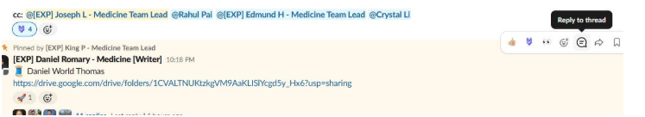

Hover over a message and click the speech-bubble icon to reply in-thread.

Who to ask
Post questions in public Slack channels and tag the relevant person — the answer helps everyone.
The first person to ask is Maven the AI chatbot. Any questions should go into the sanctumhelp channel and should @Maven.
If your answer is not answered correctly, please direct your questions to the appropriate person below:
Onboarding EPMs- [EXP] Rachel C [EXP] Lucas T
First point of contact for admin/onboarding questions: Instructions, expectations, other day-to-day needs.

Onboarding SPL- Viraj Deokar
Final point of contact for escalation, compensation or high-level contract concerns.

Onboarding Medicine Team Lead- [EXP] Joseph Lee
Final point of contact for expert knowledge related questions: World or task content, clinical logic, trap design.

Onboarding Reviewers- First point of contact to help you through the process of your Brainstorm and World Spec Docs.
[EXP] Rupal Udeshi
molybdenum.zubenelhakrabi.samarium@mercor.expert
[EXP] Robin O
electra.athebyne.algedi@mercor.expert
[EXP] Eliane G
platinum.ashlesha.naos@mercor.expert
[EXP] Stacey S
butterfly.weed.timir.dschubba@mercor.expert

🕰️ Your First 10 Hours

Your First 10 Hours on Sanctum (as of May 20, 2026)

🚀 Why this first 10 hours matters
Project Sanctum is a fast-paced healthcare AI project running on 7 day build cycles. Most writer questions and drop-offs happen in this first 10-hour window, and it is the highest-friction part of the project. If something's going sideways, ping early.
⏱ Spread your hours across the week
Several stages depend on review feedback, and reviewers need ~24 hours to turn things around.

📅 Pacing expectations
Most writers complete the full path in less than a week. Each stage has a target window. Message your Onboarding EPM or TL if something's blocking you and we'll work with you on extenuating circumstances.
🎯 End-of-week target
Approved World Spec Doc and onboarding complete!

At a glance
Stage | Hours | By the end of this stage, you'll have…
1. Setup | 0–3 | Tools set up, onboarding doc read, thread started
2. Brainstorming | 3–6 | Your first idea submitted and feedback incorporated
3. Spec Doc | 6–10 | A drafted and reviewed spec doc

Stage 1 — Hours 0–3: Setup + Onboarding
🎯 By the end of this stage: tools are working, you've read the instruction doc

Task | Time | Resources
Slack / Okta / Mercor tools setup | 30 min | Welcome to Mercor  Okta guide  Insightful Guide  RL Studio Guide.
Complete WorkRamp | 1 hr | Sign into c-mercor.okta.com to access workramp through your dashboard
Watch Onboarding Meeting Recording | 20 min | Sanctum Onboarding Recording.mp4
Read Onboarding Doc | 30 min | You’re here

✅ Done when
- You can log into Slack, Okta, RLS and Mercor
- You have completed WorkRamp
- You reached the end of this document
- You understand the key concepts of the project and are clear on next steps

Stage 2 — Hours 3–6: Brainstorming
🎯 By the end of this stage: your first idea is submitted, reviewed, revised and approved.
Task | Time
Create a personal Claude account and upgrade to the $20 Pro version. Post in the Slack Channel #incentives-bonuses-tracker once paid to be reimbursed (request access from [EXP] Rachel Cif needed) | 5 min
Develop your first idea and start a task on RL Studio. Upload your Brainstorm document, AutoQC will run automatically; address every audit item before moving forward. Once AutoQC is clean, notify the reviewers/team lead via your Slack thread that your brainstorm is ready for Human Review. | 2 hrs
Address reviewer feedback inside RL Studio (re-upload the brainstorm if needed) and update your Slack thread when revisions are ready. Repeat until the Brainstorm Human Review gate signs off with GO. | 1-2 hrs

👉For help with this stage navigate to Brainstorm Your World in Phase 1.

⏳ Feedback turnaround: ~24 hours. This wait is not logged time. Plan to submit, step away, and come back the next day to incorporate feedback — this is exactly why we ask you to spread your hours rather than cram them.

✅ Done when
- Brainstorm AutoQC has been cleared (every audit item addressed)
- All reviewer feedback has been incorporated
- Human review (Step 3 of the pipeline) has signed off with GO
What happens next
Once your Brainstorm is approved, continue onto the World Spec Phase.

Stage 3 — Hours 6–10: Spec Doc
🎯 By the end of this stage: your spec doc has been created, reviewed and approved.

Task | Time
Draft the world spec doc | 5–7 hrs
Upload your World Spec to RL Studio. World Spec AutoQC will run automatically; address every audit item before moving forward. Once AutoQC is clean, notify reviewers via your Slack thread that your spec is ready for Human Review. Address feedback in RLS and re-upload until the Human Review gate (Step 6) signs off. | 1-3 hrs

👉For help with this stage navigate to World Specification Document

✅ Done when
- World Spec AutoQC has been cleared (every audit item addressed) in RLS
- All reviewer feedback has been incorporated
- Human review (Step 6 of the pipeline) has signed off on your spec

What happens next
Once your World Spec has cleared Human Review (Step 6 of the pipeline), you have successfully completed your onboarding. You will receive an update from the Admin Team welcoming you to the project if you are chosen to continue. From here you will be added to additional Slack channels, gain expanded permissions in RL Studio (including Reference Templates curation, synthetic file review, task creation, and downstream evaluation work), have your hours increased for standard Insightful time tracking, and be looped into Tasking. Congrats!

End-of-week summary
By the end of your first week in Sanctum, you should have:
- - A deep understanding of the online platforms and tools utilized on the project (especially RL Studio)
- - A Brainstorm document that has cleared Brainstorm AutoQC and signed off at Brainstorm Human Review (Steps 1-3 of the pipeline)
- - A World Spec document that has cleared World Spec AutoQC and signed off at World Spec Human Review (Steps 4-6 of the pipeline)

Key Slack Channels
Channel | Purpose
[#general] | Main project channel for announcements and updates.
[#new-writers] | This is where you make updates to your personal slack thread on your onboarding progress and can ask questions that Maven did not properly address.
[#sanctumhelp] | AI-powered Q&A for project-specific questions. You MUST tag @Maven along with your question
Brainstorm sent back for revisions?
Take the feedback on board, spend some time refining your idea, and resubmit.
Spec doc going back and forth?
Revision is part of the process. Expect at least one round of feedback. If you're unsure what's being asked of you, drop into office hours or check this document before resubmitting.
Falling behind on the timeline?
Reach out to your pod lead as soon as you notice. Hours can sometimes be adjusted, but the sooner you flag it, the better.

💻 AI usage Policy

How to Use Claude (and Other AIs) on This Project
This page sets expectations for how Claude and other AIs (also known as Large Language Models, LLM) fit into your workflow on Project Sanctum. Read it before you start using Claude for any deliverable.
• Create a personal Claude account and upgrade to the $20 Pro version.
• Post in the Slack Channel #incentives-bonuses-tracker once paid to be reimbursed.
You may use your personal email to bypass a known SSO blocker with mercor.expert emails.
AI is a Tool, Not the Driver
The use of Claude (or any LLM) should be a guide and accelerator — not the primary driver of what you create or submit. As emphasized in Office Hours: you are the ultimate expert. Everything that is generated — spec docs, world files, supporting documents — must be double- and triple-checked by you before it moves forward.
The reason the client has engaged us is precisely because we are physician specialists who can correct, improve, and train the LLM. That value is only delivered if we critically review every piece of LLM-assisted output before submission. Skipping that step inverts the whole purpose of what we're doing here.

Signs We're Slipping into Rubber-Stamp Mode
We're seeing patterns in recent submissions that suggest critical review is sometimes being skipped:
Sign | What it looks like
LLM-generated wording | Generic phrasing, AI tells, voice that doesn't match a real clinician
Timeline inconsistencies | Dates or chronology that conflict within or across documents
Typos and small errors | Errors a careful read-through would have caught

These are exactly the kinds of issues you should be catching as the expert reviewer.
⚠️ If you're clearing your own QA in just a few minutes, that's a signal you may not be reviewing critically enough. A proper critical review of LLM-assisted content takes real time.

Non-Negotiables: 100% Human-Generated
Three components of every task must be written by you, not by an LLM. LLMs can support world-building, but the evaluation core itself must come from the physician expert. This is the foundation of the entire project.
🚫 100% human-written (no exceptions) | ✅ LLM-assisted is OK
Task prompts | Brainstorming
Golden responses | Boilerplate / drafting templates
Grader guidelines | Consistency checking

There are no exceptions to these three. LLMs can support world-building (brainstorming, boilerplate, consistency checking), but the evaluation core itself must come from the physician expert. This is the foundation of the entire project's integrity.

📺 Video Tutorial Series
Video Series A: Prompt Engineering & Multimodal Data
👉 001 How to Get Started on Claude Project - Recording | Notes
👉 002 How to Brainstorm w/ Claude - Recording | Notes
👉 003 How to Build Your World Spec on Claude - Recording | Notes
👉 004 World Spec: How to Curate Template/Reference Files - Pt. 1 & Pt. 2
👉 005 Synthesizing Multimodal Files for your World - TBD**
👉 006 Creating World & Task-level Files w/ Data Simulators - TBD**
👉 007 How to do Self-Check/QC prior to RL Studio Upload - TBD
👉 BONUS: Organizing your personal folders on Google Drive - TBD

**Note: Watch the 05/24/26 Office Hours Video – towards the end, we give a preview of how to leverage multimodal data and utilize our clinical data simulators.

Video Series B: Getting Started on New RL Studio Interface (Basic Version)
👉 001 Task Writing - Recording
👉 002 Task AutoQC - Recording
👉 003 Trajectory Runs & QC - Recording
👉 004 Failure Analysis (FA) & Grader Feedback - Recording
👉 005 FA AutoQC Review Process - Recording
👉 006 Preference Labels - Recording
👉 007 Preference Label AutoQC Review - Recording
👉 BONUS: How to Review AutoQC Failures - Recording
👉 BONUS: Reviewing Tasks and FA - Recording
👉 BONUS: How to Continue Tasks for Old Worlds (Pre-05/19) - Recording

Video Series C: Getting Started on New RL Studio Interface (Comprehensive Writer Version)

World-Building Phase:
👉 001 Uploading Brainstorm Doc + AutoQC - Pt. 1 & Pt. 2
👉 002 Uploading World Spec/Template Files/Claude Transcript + AutoQC - Pt. 1 & Pt. 2
👉 003 Review of Files from Engineering Pipeline - Pt. 1 & Pt. 2

Task-Building Phase:
👉 004 Task Prompts + Task-level Files + AutoQC- Recording
👉 005 Golden Responses: Deep Dive TBD
👉 006 Grading Guidelines: Deep Dive TBD

Agent-Runner Phase:
👉 007 Taiga/EnvLinter vs. Traj. AutoQC vs. Runs - Recording | Notes

Failure/Grading Analysis
👉 008 What is Failure Analysis (FA?) - TBD
👉 009 What is Grader Analysis (GA)? - TBD
👉 010 Writing up Your FA/GA Analysis - TBD

Preference Labeling
👉 011 What is Preference Labeling?- TBD
👉 012 How to Complete Preference Labeling (PL)?- TBD
👉 013 Preference Labeling AutoQC - TBD

…more to come…

✈️ Project Overview

Project Overview

Our Goal on Project Sanctum
Your role on Project Sanctum is of a senior clinician. You bring three things that AI cannot: the clinical instinct to imagine a realistic patient case, the skill to produce work that meets senior clinician standards, and the judgment to evaluate output against those standards. Across the workflow, you will design patient scenarios, produce senior-quality clinical work, and evaluate AI output against those standards.
Here's what we're working toward: today's best AI models still cannot reliably perform senior-quality clinical work. Project Sanctum helps train these models by placing them inside realistic simulations of clinical work environments, where they must complete the kind of assignments a practicing clinician would handle in real life.
Each World is one of these simulations: a realistic patient case containing multiple clinical tasks and the patient chart a clinician like you would navigate to complete them. An AI agent will attempt each task using only the documents in that chart. You then produce the Golden Response — the industry-standard deliverable a senior clinician would arrive at — and the gap between the agent's output and your answer becomes the training signal used to improve future models. The more realistic the World, the more valuable that signal becomes.
A fully realistic patient chart with many files and materials would take you many hours to build by hand — and most of those hours would go into producing documents that follow familiar structural patterns. Sanctum is designed so that this large-scale production can be handled efficiently by AI, while you focus your time on shaping the case itself: defining the clinical context, structuring the tasks, and ensuring the resulting environment reflects the complexity and messiness of real clinical practice.

🤖 Working with AI on Project Sanctum
Sanctum is a Claude-collaborative project from start to finish. Claude handles much of the heavy drafting — building documents, brainstorming first drafts, refining outputs — so the work is faster than doing everything by hand. Your job is part designer, part reviewer: you direct Claude on what to produce, and you own the quality of everything that leaves your hands. Only you know what's trivial in your practice area and what requires real senior judgment, and only you know what a realistic clinical assignment looks like in your specialty. The standard is professional ownership of the final product.
For every deliverable, you will rely on AI Automated Quality Check findings (AutoQC, run automatically and surfaced to you) and targeted spot-checks instead of full read-throughs.
💡 Two layers of quality checks
- AutoQC (required, formalized). Every deliverable you submit runs through automated quality checks on the project’s platform. You job is to address each AutoQC flag — fix the issue or push back with reasoning if it's a false positive. No deliverable moves forward until its AutoQC findings are resolved.
- Self-check with Claude (encouraged, informal). Before uploading any deliverable, you're encouraged (not required) to run a manual checklist with Claude — like proofreading with Grammarly before submitting an essay. This catches obvious issues early so AutoQC doesn't have to flag them.
⚠ Your professional judgment overrides AI — always. Some writers fall into the trap of treating AI's suggestions as instructions: accepting AI's framing because it sounds confident, redirecting their thinking because AI pushed back, or rewriting their work to match AI's preferred version. Don't. You are the senior clinician; AI is the assistant working for you. When AI suggests a direction that contradicts your professional judgment, follow your judgment — and push back on the AI. The training data we're producing is only as valuable as the expertise leading every decision.

💡 Our shared standards on Project Sanctum
Realism — The scenarios, patient records, and clinical tasks you create should reflect what clinicians actually produce, work with, and complete in their day-to-day clinical practice. AI can only learn to do medical work if we train it on real medical work.
Quality — AI models are only as strong as the data we give them. Your responsibility is making sure each deliverable is realistic and consistent with your World, using AutoQC + targeted spot-checks rather than full read-throughs.
Attention to detail — The work is long, complex, and interconnected. AutoQC is embedded throughout this project to check and surface inconsistencies for you. Your job is to engage seriously with each finding: fix real issues, push back on false positives. The best experts treat AutoQC feedback as the trigger for their attention, not as something to skim past.
Your judgment leads — When Claude suggests a direction that contradicts your professional judgment, follow your judgment. Claude doesn't know your clinical specialty; you do.
Professionalism — You'll be reviewing each other's work, and disagreements will come up. Give each other the benefit of the doubt. When you flag a concern, be specific and constructive. When you receive feedback, engage with it seriously. When you and a reviewer disagree, escalate to a Team Lead with your reasoning — don't silently work around it. Direct, thoughtful dialogue is the norm here.

💡 The Driving Question
How do I design a clinical environment that holds the workflows I’m required to complete, in a way that reflects the challenges of my day-to-day work and requires my expertise?
You know what professional-grade clinical work looks like — the format a senior clinician expects, the diagnostic depth patient safety requires, the judgment that comes from years of clinical practice. Think of the AI as someone just starting in your domain — freshly board-certified, or in their first year as a medical director — capable and knowledgeable, but without the seasoning that years in your specialty build. You're the seasoned one. The gap between someone just starting and someone seasoned is exactly the gap your tasks should expose.

The Three-Column Mental Model
Three roles operate in parallel: the work you produce, what the AI does with it, and what we mean by "good." Hold all three columns in mind whenever you're designing.
1. What you + AI produce | 2. What the AI model does | 3. What "good" means
A complete clinical environment package.  A realistic patient case (or multiple cases) and the surrounding clinical environment — including the scenario, multiple sources of information (EHR documents, patient-provided records, photos, external faxes, portal messages), patient records, and the clinical workflows that emerge from them. | An AI Agent attempts each clinical workflow by navigating the World files and working from the materials and instructions provided. | Everything you produce should be realistic clinical work, solvable by a strong clinician from the World files alone but too challenging for today's best AI to do well.

The Three Core Concepts
Three concepts form the spine of the project: Scenario, Task, and World. They build on each other in an order, and understanding how they relate is the foundation everything else rests on.
Concept | What it is | How you establish it
World | The clinical environment you operate in — anchored in your role, your specialty, and the setting where you work. The World is the umbrella that holds your patient case, your clinical assignments, and the chart files the AI agent will navigate. | You start by naming your role ("I'm a hospitalist," "I'm a medical director in dermatology," "I'm an urgent care physician"). After your scenario and tasks are designed, the World files — the actual patient chart + any supporting documents — are generated and you review them before approving the build.
Scenario | A realistic patient case. It describes who the patient is, what their clinical situation is, and why care is happening now. | You brainstorm your patient case from your practice that fits your World — drawing from a case you'd realistically encounter in your role.
Task | A realistic clinical workflow an AI agent attempts to complete — the end-to-end work required to produce a specific deliverable (a discharge summary, a med reconciliation, a consult note, an RCA report). You'll design 8+ tasks per World, each mapped to one workflow on the approved list. | You sketch the 8+ workflows you'd realistically perform for that patient.

Start with your role
Before you brainstorm a scenario, sketch task ideas, or think about what materials or files belong in your World, anchor yourself in your role. Every clinician on this project comes in with a specialty and a setting — that's your starting point.
You might be a hospitalist managing inpatient admissions, a medical director reviewing peer cases, an urgent care physician handling walk-in evaluations, a dermatologist running an outpatient clinic, or a coding specialist auditing inpatient claims. Whatever your role is, that is the lens through which every design decision flows.
Your role determines:
- Which patient cases come to mind when you brainstorm your scenario
- Which workflows you'd realistically perform for that patient
- Which documents naturally exist in that working environment
- What "expert-quality" output looks like at the end
💡 A Simple Way to Think About this:
1. Your role — "I am a [specialty] in [setting]."
2. Your scenario — A patient case from my practice.
3. Your tasks — The workflows I'd complete for that patient.
4. Your World — The clinical environment that holds the case and supports the tasks.

How a World Comes Together
Here is the full sequence from start to finish. AI does the heavy drafting throughout; your role is to design, decide, and review.
Make a plan ← design your scenario + task ideas
↓
Build your World ← the patient chart + any additional materials
generated from your plan
↓
Review the built World ← confirm realism and complexity

🚣 Project Workflow

Project Workflow

The full pipeline is 17 steps divided into 4 phases. At a high level: you design the patient and clinical environment (World), engineering generates the synthetic chart from your approved spec, you write the clinical requests against that chart (Tasks), clear the automated and human QA gates, then grade and analyze how the AI performed (Evaluate).

Everything lives in RL Studio. As of May 20, 2026, every major deliverable — brainstorm, world spec, reference templates, synthetic files, task prompts, golden responses, grader guidelines, Failure Analysis, and Preference Labels — is uploaded, audited, and signed off in RLS.
Project Workflow

Here is the full sequence from start to finish. At a high level: you design the patient and the clinical environment (World), engineering generates the synthetic chart from your approved spec, you write the clinical requests against that chart (Tasks), clear the automated and human QA gates, then grade and analyze how the AI performed (Evaluate).

Everything lives in RL Studio. As of May 20, 2026, every major deliverable - brainstorm, world spec, reference templates, synthetic files, task prompts, golden responses, grader guidelines, Failure Analysis, and Preference Labels - is uploaded, audited, and signed off in RLS.

*** YOUR ONBOARDING SCOPE: You complete Steps 1-6 only. ***
During onboarding, you do the Brainstorm cycle (Steps 1-3) and the World Spec cycle (Steps 4-6). You do not curate Reference Templates during onboarding - veteran writers add the templates folder at Step 4. The rest of the pipeline (Steps 7-17) is shown below for context so you understand where the work goes once you transition to the veteran writer cohort. DO NOT CONTINUE PAST STEP 6 UNTIL APPROVED BY TL/EPM/SPL.

Phases at a glance:

| Phase | Goal | Steps |
| Phase 1 - Plan Your World | Design a realistic clinical scenario and document the spec. | 1-6 (Onboarding ends here) |
| Phase 2 - Build Your Files & Tasks | Engineering generates synthetic files from approved spec + reference templates. Writer reviews files and writes 5-10 tasks in RLS. | 7-11 (Veteran writers) |
| Phase 3 - QA Your Tasks | Address Task AutoQC findings and complete the Taiga QC pass. | 12-13 (Veteran writers) |
| Phase 4 - Evaluate the Agent | Write FA + PL, clear the FA + PL AutoQC, and pass Final Reviewer Review. | 14-17 (Veteran writers) |

Production Pipeline - 17 Steps

WORLD BUILDING (you do these during onboarding)
1. Brainstorm - High-level plan for world design and task ideas. [RL Studio, Slack]
2. Brainstorm AutoQC - Automated check on the brainstorm before human review. [RL Studio]
3. Human Review (Brainstorm) - Pod lead or peer reviewer signs off. GO or SEND BACK. Address audit items before moving forward. [RL Studio, Slack]
4. World Spec Document - Develop the full world specification. (Veteran writers also upload a Reference Templates folder at this step; during onboarding you upload the spec only.) [RL Studio]
5. World Spec AutoQC - Automated check on the world spec. [RL Studio]
6. Human Review (World Spec) - Reviewer signs off on your spec. ***ONBOARDING ENDS HERE.*** [RL Studio]

BUILD (veteran writers only)
7. Synthetic Generation Pipeline - Engineering's pipeline auto-extracts the approved spec and reference templates and generates the synthetic files. [RL Studio]
8. World AutoQC - Automated check on file integrity, schema, and world consistency. [RL Studio]
9. Writer Reviews Files - Writer reviews generated files; minor issues edited in place, major issues regenerated by engineering. [RL Studio]

RUN (veteran writers only)
10. Set Up Tasks in RLS - Upload task files, draft task prompt, golden response, and grader guidelines directly in RLS. [RL Studio]
11. Run the Agent - Run all tasks and wait for output (~1 hour). [RL Studio]

QA (veteran writers only)
12. Task AutoQC - Automated check on task quality. Runs after task setup (Step 10) and again after agent run (Step 11). [RL Studio]
13. Taiga QC - Trajectory + grading audit. [Taiga / RL Studio]

EVALUATE (veteran writers only)
14. Failure Analysis (FA) - Compare lowest-scoring trajectory to golden. Write the FA paragraph and the Grader Analysis paragraph. [RL Studio / Taiga]
15. Preference Labeling (PL) - Compare two attempts. Select preferred. Justify across seven-section format. [RL Studio / Taiga]
16. AutoQC on FA + PL - Automated quality check on FA writeup and PL justifications. [RL Studio]
17. Final Reviewer Review - Team Lead, pod lead, or EPM signs off for delivery. [RL Studio]

🏭 Production Pipeline

Phase | Production Pipeline | Platform/s
Brainstorming | Set up Claude | RLS,  Google Drive, Claude, Slack
 | Writing in progress (pre-review)
 | Submit for team review
 | Review in progress
 | Writer revisions in progress (post-review)
 | Ready for final sign off
 | Approved (ready for world spec)
World Spec | Writing in progress (pre-review)
 | Submit for team review
 | Review in progress
 | Writer revisions in progress (post-review)
 | Ready for final sign off
 | Approved (ready for file generation) — Onboarding ends here!!!
World-level Files  (synthetic file generation) | V1 file generation in progress
 | V1 ready for writer review
 | V1 writer review in progress
 | V1 writer revisions submitted (ready for v2)
 | V2 received from engineering team
 | V2 review in progress
 | V2 writer revisions submitted (ready for v3)
 | V3 received from engineering team
 | V3 review in progress
 | World-level files approved by writer
Final review by pod lead / Team Lead / reviewer
Writer moved from New Writer to a MAIN POD
Task-Level Materials  (Task Prompts, Grader Guidelines, Golden Responses) | Finalize task-level materials  (Task prompts, grader guidelines, golden response)
 | Submit for pod lead/peer review
 | Revisions in progress (post-review)
 | Submit for final sign off
 | Package and organize in Google Drive (ready for RLS upload)
Quality Assurance (QA) | Set up World in RLS (by team lead or pod lead) | RL Studio, Slack
 | World upload complete (ready for trajectory run)
 | Run trajectories
 | Trajectories complete (ready for QA)
 | Automated QA feedback by EnvLinter
 | Review and document response to QA feedback
 | Make task-level (or world-level) changes based on QA feedback
 | Re-run trajectories
 | Review automated QA by EnvLinter (V2)
 | Document response to QA feedback (V2)
 | Incorporate task-level changes based on QA feedback (V2)
 | Rerun trajectories
 | Review automated QA by EnvLinter (V3)
 | Review and document response to QA feedback (V3)
 | Incorporate task-level changes based on QA feedback (V3)
 | Rerun trajectories
 | Final review of QA and world sign off
Write failure and grader analysis for each task
(choose lowest scoring trajectory)
 | Preferential labeling
 | Final team review
 | World approved by team (ready for client delivery)

📋 Phase 1: Plan Your World

Phase 1: Plan Your World
🎯 Estimated read time: ~20 minutes
By the end of this section, you will be able to:
- Explain what a World, a Scenario, and a Task are, and how they relate to each other
- Identify what makes a World realistic (realism, difficulty, evaluability)
- Describe what goes into a World — clinical document types, file range, and the difference between essential and supplementary files
- Define what a trap is and recognize the six most effective trap types
- Understand how failure modes are built into World files to challenge AI agents
- Confirm your understanding using the self-review checklist

Part 1: Understanding how this project produces data
Before you write a specification, you need to understand what you are building and why it matters. This part covers the fundamentals: what a world is, what goes in it, and how it connects to the tasks an AI agent will attempt. Master this first — the specification process in Part 2 builds directly on these concepts.

What is a World?
Every task begins with a world — and each world supports 5–10 tasks.
A world is a complete, self-contained file environment built around a single patient case. It is the workspace the AI agent operates in: the full set of clinical documents available to it when it attempts your tasks — progress notes, lab results, imaging reports, consult notes, medication lists, nursing assessments, discharge summaries, and outpatient records.
Think of it this way: a world is a patient's complete chart. Every note, every lab, every consult, every order that would exist for that patient is in the chart. Nothing is flagged. Nothing is summarized for the agent. It has to figure out what matters, just like a physician would.
The agent has no information beyond what is in the world and what you tell it in the task prompt. Traps are not realistically and intentionally designed to simulate real-world points of friction. It cannot search UpToDate, call a specialist, or draw on anything outside the files you provide. Your job is to construct a clinical environment where the agent's reasoning can be rigorously tested — enough material for it to reach correct conclusions through careful reading and synthesis, but enough complexity, contradictory findings, and buried detail that doing so requires genuine clinical skill.

What Goes Into A World?
Now that you know what drives a world, here is what actually goes in it.
A world contains many documents. These are the clinical files the agent will have access to when it attempts your tasks. They should be the kinds of documents a physician working on your patient would actually encounter in an EMR — not a curated set of only the relevant ones, but a realistic chart that includes both essential files and realistic noise.
A world typically contains a mix of the following document types — the same kinds of files you would find in a real patient chart:
- Progress notes (daily attending notes, resident notes, overnight coverage notes) — the running narrative of the patient's hospital course, where key clinical decisions, exam findings, and plan changes are documented.
- Lab results (CBC, BMP, CMP, coagulation studies, trending values across days) — necessary for any task that requires tracking clinical trajectories or dosing decisions.
- Imaging reports (chest X-rays, CT scans, ultrasounds, MRIs) — where radiologic findings are interpreted, sometimes with discrepancies between preliminary and final reads.
- Specialist consult notes (cardiology, nephrology, GI, pulmonology, etc.) — where recommendations may conflict with each other or with the attending's final plan.
- Medication lists and orders (home medication lists, active inpatient orders, medication administration records, verbal orders) — the core of any reconciliation task, where copy-forward errors and ambiguity naturally accumulate.
- Nursing documentation (nursing flowsheets, vital signs, I/O records, nursing assessments) — adds granularity and realism, and may contain observations not reflected in physician notes.
- Discharge and transfer documents (discharge summaries, transfer notes, referral letters) — where information gets synthesized and where errors from earlier documentation often propagate.
- Patient-provided documents (handwritten medication lists, outside records, advance directives) — may contain inaccuracies that conflict with the chart.

- Administrative documents (insurance authorization forms, coding sheets, quality metric reports) — support healthcare administration tasks like prior auth, E/M coding, and HEDIS review.

What is a Scenario?
A scenario is the starting point of every world — the patient case that gives all the documents a reason to exist in one place. It describes the patient, their medical history, the admission event, and the clinical course that makes all tasks simultaneously active.
A good scenario answers three questions:
What is the clinical context?
The care setting, the reason for admission, and where the patient is in their hospital course?
Who are the key players?
The patient, their family, the attending, the consulting specialists, and the care team?
What is the precipitating event?
The single development (or cascade of complications) that makes all tasks simultaneously live?
Your scenario should be describable in a short paragraph. The world is everything that exists around it: the progress notes, lab results, imaging reports, consult notes, medication lists, and orders that a physician working on the case would have in the chart. You will build that full clinical document set in your World Spec.
The best patient profiles feel like someone you have actually taken care of. A colleague reading the chart should nod and say: "I've had this patient."
✅ Strong Patient Example
A 74-year-old male with CHF (EF 30%), CKD stage 3b, type 2 diabetes, atrial fibrillation on apixaban, GERD, and COPD. Admitted for CHF exacerbation, develops hospital-acquired AKI and upper GI bleed on day 3. Cardiology and Nephrology disagree on restarting ACE inhibitor and spironolactone. GI and IR disagree on bleed management. 11-day hospitalization with 26 home medications requiring reconciliation, then presents 2 weeks post-discharge to urgent care with a new complaint.

Why this works: Common conditions interact in realistic ways. Every complication triggers medication changes. Specialist friction creates split decisions that prevent simple heuristics. The long stay generates a deep document trail with natural copy-forward errors.

❌ Weak Patient Example
A 28-year-old previously healthy female who presents with sudden-onset hemoptysis, found to have Goodpasture syndrome with concurrent anti-NMDA receptor encephalitis and pheochromocytoma.

Why this fails: Stacking three ultra-rare diagnoses tests trivia recall, not clinical reasoning. No meaningful trap opportunities, no polypharmacy, no specialist friction that mirrors real practice. If you need a zebra diagnosis to make a case hard, the case is contrived.

Designing Strong Patients
Your patient is the foundation of the scenario — and the foundation of everything in your world. The best patient profiles feel like someone you have actually taken care of. A colleague reading the chart should nod and say: "I've had this patient."
Strong patient profiles typically feature:
- Multiple active comorbidities (10+) whose treatments interact
- Polypharmacy (15+ medications) creating reconciliation complexity
- Multi-day hospitalizations with specialist involvement and split decisions
- Cascading complications where each problem triggers medication changes that affect the next
- Realistic social and administrative complexities, such as fragmented documentation across multiple records, limited or unreliable history (e.g., foster care, estranged family), insurance or prior authorization barriers, care coordination challenges across systems, etc.

Complexity should emerge naturally from the intersection of common conditions — not from stacking rare diagnoses.
⚠️ Important: Use fictional patients in your scenario. AI agents have access to training data. Using real patient cases from published literature or case reports creates a risk that the agent will draw on outside knowledge rather than reasoning from your World files. All patient names, dates, and identifying details must be fictional. To ensure names do not correspond to real individuals, err on the side of caution and use clearly fictional names.
Examples: Johnny Elephante, Tommy Tambourine

What Is a Task?

You will not write tasks in Phase 1, but understanding what a task is will directly shape how you design your World — which files to include, what traps to embed, and how to scope your scenario.
A task is the end-to-end representation of a legal workflow within a specific world and scenario.

A task is a specific clinical request directed at an AI agent within a specific world and scenario.

A task is a realistic clinical assignment that an AI agent attempts to complete using only the files in your World. Think of it as an instruction an attending might give a covering resident, or a workflow a care team needs completed during a hospitalization: reconcile these discharge medications, draft this consult note, complete this prior authorization. The agent receives your written prompt, accesses the World files, and attempts to produce the requested work product. It has no prior context about the patient beyond what is in the World and what you tell it in the prompt — think of it as a capable but uninstructed clinician sitting down to a chart for the first time.

Every task must meet three requirements:
- Represents real clinical work. The task must be something a physician or clinical team member would actually perform: medication reconciliation, discharge summary drafting, consult note writing, diagnostic reasoning, coding determinations, and applying clinical guidelines.
- Produces a concrete, evaluable output. A medication list, a discharge summary, a consult note, a coding determination, an authorization letter. If you cannot articulate what a correct output looks like, the task is not viable.
- Elicits model failure. The agent's response must contain a material clinical deficiency. This is what makes the task useful for AI training.

✅ GOOD TASK EXAMPLE
Workflow: Medication Reconciliation at Discharge
Prompt: “I’m the covering resident preparing Mr. Pemberton for discharge after an 11-day admission for CHF exacerbation complicated by upper GI bleed and AKI. Please reconcile his discharge medication list using the attached documents.

Why this works:
- Real clinical work — medication reconciliation at discharge is a workflow physicians actually perform every day.
- Concrete, evaluable output — a medication list with annotations is a deliverable a grader can score against a defined standard.
- Elicits model failure — specialist disagreements about anticoagulation, a vague "resume home meds" order, and dose changes during AKI all create material opportunities for the model to make clinical errors.
- “Fair game” question — If you had asked 100 seasoned physicians this exact question and you have provided them with the world-level files necessary for self-containment, 95% of them would be able to complete the task satisfactorily without needing to ask follow up questions.

Note: There are additional elements in task prompts that make this strong. These prompt design principles are covered in detail in Task Prompt section in Phase 2. For now, focus on whether your task ideas meet the three requirements above; you'll learn to write the prompt itself in Phase 2.

❌ BAD TASK EXAMPLE
Workflow: General Clinical Question
Prompt: “What medications should be stopped?”
Why this fails:
- Not a real-world clinical deliverable - Our questions have to simulate a real-world clinical deliverable from our list of approved workflows. It is not clear what this is simulating from our list of clinical workflows.
- Unclear ask — "Should be stopped" is ambiguous: Should be stopped when exactly? Today? Tomorrow? At discharge? Post-discharge?
- Unlikely to yield model failure — The question does not provide enough room for nuance. Instead of asking for a medication discharge reconciliation list, which can include medications with dosage changes or new medications altogether, the question is too narrow and deterministic and thus increases the likelihood of the model getting the answer correct.
- Not a “Fair game” question — If you had asked 100 seasoned physicians this question, the majority of them will have follow up questions. It would not be fair game for them to tackle this task and get it right on the first try because the question is framed poorly.

Why this matters for World Building
Remember: your world exists to support 5–10 tasks, and every design decision you make should be informed by the tasks you are contemplating. Four principles to keep in mind as you plan your World:
Tasks must be answerable from the World files. The agent can only work with what is in the World and what you tell it in the prompt. If a task requires a clinical finding, a lab value, or a medication order, the relevant document must be in the World.
Good tasks require cross-document reasoning. Tasks where the agent can succeed by pulling a single fact from a single document are not useful. This means your World files should distribute key information across multiple documents — the agent should have to find, connect, and synthesize to reach a correct answer.en
The agent sees everything. You cannot hide files from the agent. This means all World content must be logically consistent with your tasks. If something in the World contradicts a task, the agent will find it.
Tasks should be diverse. Your 5–10 tasks should span different clinical workflows, output types, and reasoning demands. This means your scenario needs to be broad enough — and your file set rich enough — to support a range of distinct assignments. A scenario that only supports one type of task is too narrow.
Detailed guidance on how to write task prompts, create golden responses, and prepare grading guidelines will be covered in a future phase.

What is a Trap

A trap is a deliberate point of friction embedded in your World files — a place where a careful reader would catch a problem but a less attentive one would not. Traps are not errors in your work. They are intentional design choices: a medication that was changed but never updated on the active list, two specialists who gave conflicting recommendations without resolution, a lab value from Day 1 that no longer applies on Day 8 but was never flagged as outdated.
Traps live in the documents, never in the task prompt. The agent discovers them — or fails to — by reading the chart. This is exactly how real clinical risk works: the information is there, but finding it and acting on it correctly requires judgment.
A well-designed trap has three properties: it is clinically plausible (it could happen in a real chart), it is discoverable (the information needed to catch it exists in the World files), and it produces a meaningful error when missed (not a trivial formatting difference, but a clinical decision that changes).

The Most Common & Effective Trap Types
Trap Type | How It Works | Examples
Copy-forward errors | Outdated information carried forward across documents without being updated. Models tend to trust whatever appears most recently in the chart without checking whether it has been superseded. | A pre-admission medication list still shows a drug discontinued during the hospitalization. The agent includes it on the discharge list.
Specialist friction | Conflicting recommendations from different services, with a split attending decision. The correct answer requires tracing the disagreement to the attending's final decision. | Cardiology recommends restarting lisinopril; Nephrology recommends holding it; the attending sides with Nephrology. The agent follows the most recent consult note instead of the attending's decision.
Temporal contamination | Information from the wrong time point mixed into the current context. Models tend to treat all documents as contemporaneous. | Day-1 lab values used to make a day-11 decision, or a discharge summary included in a file set for a task anchored to day 7.
Authority ambiguity | Unclear which source should take precedence when documents conflict. | A verbal attending order contradicts the most recent progress note, or a resident's plan differs from the specialist's recommendation without documented resolution.
Resume order traps | A vague "resume home medications" order in the context of a patient who had multiple medication changes during the admission. | The patient had 8 medication changes during admission. The correct answer requires full reconciliation, not execution of the shorthand order.
Patient-provided inaccuracy | A patient or family member provides a document that conflicts with the chart. The model must recognize the conflict, not simply defer to whichever it reads last. | An outpatient pharmacy record contradicts the patient's notes on their phone.  A daughter brings a handwritten medication list including discontinued drugs and missing new ones.

What Separates a Strong Trap from a Weak One
The table above tells you what kinds of traps to build. This section shows you the difference between a trap that works and one that does not.
❌Weak trap: Single-file, single-error
A lab report lists potassium as 5.8 mEq/L, but the progress note from the same day documents it as 4.2 mEq/L.
Why this is weak: The discrepancy lives between only two documents and involves a simple numerical mismatch. The agent can catch it by comparing one value against another — no clinical reasoning required. This is a data-checking task, not a clinical judgment task.

Weak trap: Bypassable with general knowledge
The world files include a medication order for metformin in a patient whose most recent creatinine is 3.2. The trap relies on the agent knowing that metformin is contraindicated in severe renal impairment.
Why this is weak: Any model with access to general medical knowledge or web search can flag this. The trap tests factual recall, not chart navigation or synthesis. The agent does not need to engage deeply with your world files to get this right.

Strong trap: Cross-document synthesis required
A cardiology consult on Day 3 recommends starting anticoagulation with apixaban. A nephrology consult on Day 5 notes declining renal function and recommends dose-adjusting all renally cleared medications — but does not specifically mention apixaban. The pharmacy medication list on Day 6 still shows the original apixaban dose. The discharge summary task requires medication reconciliation.
Why this is strong: The agent must find the cardiology recommendation, connect it to the nephrology note's general guidance about renal dosing, recognize that apixaban is renally cleared, notice that the pharmacy list was never updated, and determine the correct adjusted dose. This requires reading across at least four documents and applying clinical reasoning to connect them. A model that only reads the pharmacy list will produce an incorrect reconciliation.

Strong trap: Conflicting specialist recommendations
A pulmonology consult recommends continuing high-dose corticosteroids for an acute COPD exacerbation. An endocrinology consult from the same day recommends tapering steroids urgently due to worsening hyperglycemia and early steroid-induced myopathy. Neither consult references the other. The task asks the agent to write a discharge plan that addresses both the pulmonary and endocrine management.
Why this is strong: There is no single correct answer that satisfies both specialists' recommendations simultaneously. The agent must identify the conflict, weigh the competing risks, and justify a clinical approach. A model that follows one consult without acknowledging the other will produce a flawed discharge plan.

Strong trap: Temporal reasoning across the admission timeline
A patient is started on vancomycin on Day 1. A trough level drawn on Day 3 comes back elevated. The pharmacist recommends holding the next dose in a note buried in the pharmacy section. The Day 4 nursing medication administration record shows the dose was still given. The Day 5 labs show a further rise in trough level plus a new acute kidney injury. The task asks the agent to document an adverse drug event analysis.
Why this is strong: The agent must reconstruct a timeline across pharmacy notes, nursing records, and lab results spanning five days. The critical failure point — the dose that should have been held — is documented in a pharmacy note that is easy to overlook if the agent does not systematically review all medication-related documents in chronological order.
Check your traps against these questions:
Does solving this trap require reading three or more documents? If the agent can catch it from one or two files, it is probably too easy.
Would a model with strong general medical knowledge but no access to the chart still get it wrong? If general knowledge is sufficient, the trap is not testing chart navigation.
Is the plausible wrong answer something a careful but imperfect reader might actually produce? If the wrong answer is obviously absurd, the trap has no teeth.
Does the trap arise naturally from the clinical scenario, or does it feel artificially inserted? Traps woven into the patient's story are stronger than traps that require inventing unrealistic errors.

How Do They Connect?
The four core concepts you just learned — World, Scenario, Task, and Trap — form a single design chain. Each one shapes the next:
Your scenario defines the patient case — who the patient is, what happened, and why everything is active at once. It is the reason all the documents in your World exist in one place.
Your World is the complete clinical environment built around that scenario. It contains every document the AI agent will have access to — and nothing else. The agent cannot look beyond the World, so the World must contain everything needed to answer your tasks.
Your tasks are the clinical assignments the agent attempts using the World files. Each task tests whether the agent can do real clinical work: find the right documents, interpret them correctly, and produce a defensible output. The tasks are what give the World its purpose — without tasks, the World is just a collection of files.

Your traps are what make the tasks genuinely difficult. They live in the World files, not in the task prompt. A copy-forwarded medication list, a specialist recommendation the attending overruled, a lab value from the wrong day — the agent has to discover the problem by reading carefully, the same way an attentive physician would.
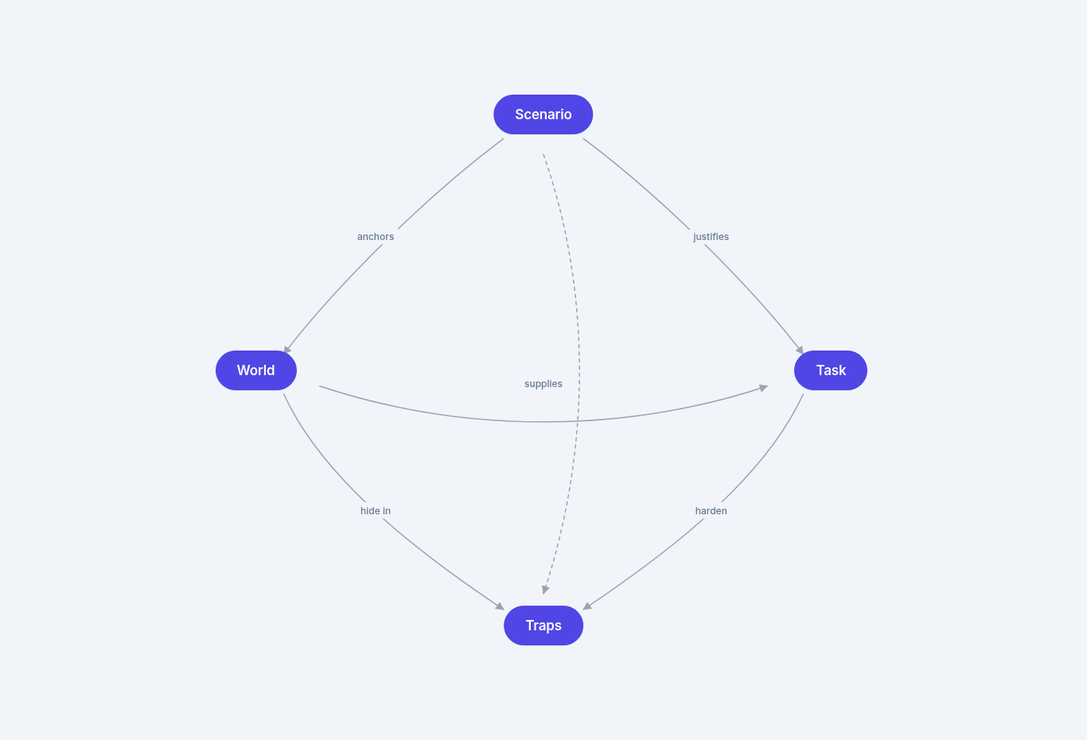
The design process is not purely linear — your trap ideas may cause you to adjust your patient's comorbidities or clinical course, your task ideas will shape which files you need, and the files you have access to may change which tasks are viable. Expect to iterate.

What Makes A World Realistic?
Property | What It Means | Ask Yourself
Realism | The scenario, documents, and tasks reflect how clinical work actually happens — including the messiness, information gaps, and moments where judgment is required. | Would a physician look at this chart and recognize it as realistic?
Difficulty | The difficulty comes from the documents and from applying domain knowledge to those documents — not from trick wording in the prompt. | Is this hard because of the medicine, or hard because the prompt is confusing?
Evaluability | Every task produces a concrete output that can be graded. If you cannot articulate what a correct answer looks like, the task is not suitable. | Can I write a definitive correct answer for every task in this world?

Of these three, realism is the most important. A World that feels contrived is not useful, even if it produces difficult tasks. Your documents should look like something a physician would actually find in a patient chart, not materials arranged to manufacture a specific outcome.
Difficulty should emerge naturally from the complexity of the clinical scenario and the documents, not from rare diagnoses or deliberately confusing file organization. If your World requires the agent to reconcile conflicting specialist recommendations, trace medication changes across a multi-day hospitalization, and synthesize findings from progress notes, lab trends, and consult notes, the difficulty will take care of itself.
Evaluability is your design constraint: every task you plan for this World must produce a concrete output that can be graded. If you find yourself thinking "there's no right answer to this," either rethink the task or adjust the World files until a defensible answer becomes articulable.

Part 1 Self-Review Checklist
Before moving to Part 2 (Writing Your World Specification), confirm every item:
- Can you explain what a world is in one sentence?
- Can you describe the difference between a Scenario and a World?
- Can you explain why understanding Tasks matters for World Building, even though you won't write them in this phase?
- Do you know what makes a World realistic? (Realism, Difficulty, Evaluability)
- Can you describe what goes into a World, including clinical document types and the difference between essential and supplementary files?
- Can you define what a trap is and name at least three of the five trap types?
- Do you understand why no single file should give the agent everything it needs?
- Do you know what makes a bad trap? (prompt inconsistency, inappropriate versioning, over-authoritative summaries)
- Do you understand how the four core concepts connect? (Scenario creates World, World contains files, files support Tasks, traps make Tasks hard)

🔄 RLS Workflow
STUDIO WORKFLOW GUIDE
World Planning and Brainstorming
Step-by-step reference for new and returning writers
Please begin by watching the step-by-step video guide.
This guide walks through the brainstorming and world planning workflow in RL Studio (RLS). Previously this work was done in Airtable or Google Docs only; moving forward, every stage lives in RL Studio. The guide is written primarily for new writers, but veterans will find the workflow reference useful as well.
For help accessing RL Studio, please follow these instructions: RL Studio Guide.
The workflow has two sequential stages, each gated by human review:
- Brainstorming / Planning — upload your planning document.
- World Spec Drafting — upload the full spec.
The golden rule: AutoQC must be run at every stage, and all valid feedback must be addressed before submitting for human review. AutoQC improves over time, and skipping it is the most common cause of rework.

Stage 1: Brainstorming and Planning

1.1 Get into the right world
After logging into RL Studio, accept the invite to the Live World Creation and Planning world. This is where all task phases for world planning and brainstorming take place.
- Left handside: Dashboards > My World Building Tasks
- Confirm drop down = [LIVE] World Creation and Planning

1.2 Create your task
- Click Create Task.
- You'll now be in the drafting view, where you can create or upload your brainstorm, run AutoQC, and submit for review.
- Select your Pod as New/Onboarding

1.3 Upload your brainstorming document
- Click Upload.
- Select your brainstorming/planning document from your computer.
- Confirm the upload completed.

1.4 Run AutoQC
- Click to run AutoQC on the uploaded document.
- Wait for the results to populate. You can also view results under the AutoQC section of the task — note that the WorldSpec AutoQC option shown here is for the next stage and won't fetch anything useful yet.
- Review every item AutoQC returns:
- Valid feedback — make the change in your document, re-upload, and re-run AutoQC to confirm the fix is sufficient.
- Feedback you disagree with — write down notes explaining why, so you have a clear answer if a reviewer asks about it.
Running AutoQC and reviewing the results is required before submitting. Do not skip this step.

1.5 Mark diagnostics reviewed and submit
- Once you've worked through all AutoQC results, click Mark Diagnostics Reviewed.
- Submit your plan for review.
The task status will move from Plan Drafting to Ready for Plan Review.

1.6 What happens during review
- Ready for Plan Review — waiting for a reviewer to pick it up.
- In Progress — a reviewer is actively reviewing.
- Approved — you can move on to World Spec Drafting (Stage 2).
- Needs Fixes — the reviewer has comments to address.

1.7 Handling “Needs Fixes”
- Open the task and read the reviewer's feedback (visible directly in RL Studio).
- Click Start Plan Fixes to return to drafting.
- Delete the old document if needed, upload the revised version.
- Re-run AutoQC.
- Resubmit.
Communication tip: All feedback should be communicated in RL Studio so everything is tracked in one place. Slack is fine for quick back-and-forth with your reviewer to speed things up, but the official feedback record lives in RL Studio.

Stage 2: World Spec
NOTE: do not continue in RL Studio to draft your world spec. See the “World Spec documentation” tab to review how to draft your world spec. This stage here only refers to once you’ve already got your world spec drafted (covers how to upload and run in RL studio).

Once your brainstorming document is approved, the task status becomes Ready for Spec Drafting.

2.1 Start the stage
- Click into the task.
- You'll now see your approved brainstorming document from the previous stage available for reference, plus an option to upload a World Spec document.
- Click Start Spec Drafting.

2.2 Upload spec and template/reference files
- Upload your World Spec document.
- Upload any template/reference files needed for the spec (used by the engineering team to create synthetic files for your world).

2.3 Run AutoQC (again, and seriously this time)
Run the spec-stage AutoQC. This one is particularly reliable — if there are issues here that you don't address, you will almost certainly receive reviewer feedback about them. Save yourself the round-trip:
- Work through every flagged issue.
- Re-upload and re-run AutoQC until clean (or you have documented disagreement).
- Mark diagnostics reviewed.

2.4 Submit for spec review
Submit. The review process is identical to Stage 1:
- Ready for Spec Review — waiting
- In Progress — reviewer is working on it
- Approved — move to pipeline stage
- Needs Fixes — click Start Spec Fixes

2.5 Handling spec fixes
When fixes are needed, the fix view shows both the planning-stage feedback from Stage 1 and the current spec-stage reviewer feedback. Work through them, upload your updated documents, run AutoQC, and resubmit.
That completes the workflow for onboarding!
Quick Reference: Task Statuses
Status | What it means | What you do
Plan Drafting | You're working on the brainstorm | Upload, run AutoQC, submit
Ready for Plan Review | Submitted, waiting | Wait
Plan In Progress | Reviewer is working on it | Wait
Needs Plan Fixes | Reviewer has comments | Start Plan Fixes, address feedback, resubmit
Ready for Spec Drafting | Plan approved | Start Spec Drafting
Spec In Progress / Needs Spec Fixes | Same pattern as plan | Same pattern as plan
Spec Doc Approved | Ready for a Pod | Wait for EPM

Things That Will Save You Time
- Run AutoQC at every stage. It catches the exact issues reviewers will flag.
- Address every valid AutoQC item before resubmitting. Re-run AutoQC after edits to confirm.
- Document any AutoQC items you disagree with. A short note is enough.
- Follow the naming conventions from the onboarding guide when setting up workspaces.
- Keep feedback in RL Studio as the source of truth, but use Slack with your reviewer for fast clarification.
- Ask in Slack if anything is unclear. New writers especially benefit from working closely with their reviewer.

🧠 Brainstorm Your World

Before Your Start: Brainstorm Your World

World Brainstorm Checkpoint
Conceptual sign-off before world spec drafting begins

Purpose
This checkpoint exists so you do not invest weeks in a full world spec built on a foundation that will not hold up. The bar at this stage is conceptual viability, not spec quality. The lead is signing off on "this idea is worth building out," not on "this is a finished design."

Output of the checkpoint is binary: go or send back. If sent back, the writer revises the brainstorm and re-presents.

What the writer brings
A brainstorm in either bullet or short narrative form, covering the four elements below. No file inventories, no document drafts, no full timeline yet. This is a concept pitch.

🎨 Brainstorm Template
Brainstorm Template
NOTE: Feel free to slightly modify as you see fit

Element | What to bring | Examples
1. World setup | Who the patient is and what clinical situation the world represents:  • Demographics and comorbidities  • Clinical environment (specialty, inpatient vs. outpatient vs. administrative oversight)  • Encounter type (admission, clinic visit, RCA review, peer review, coding audit, and so on)  • Shape of the timeline; what changes over the course of the world  Enough to know the world is medically and contextually coherent. | "This is an inpatient hospital medicine world: a [N]-day admission for [presenting problem] in a [age] [sex] with [comorbidities]."  "This is an outpatient primary care world: a single clinic visit for [chief complaint] in a [age] [sex] with [relevant chronic conditions]."  "This is a medical director world: an RCA review of [event type] involving a [age] [sex] who [outcome]; reviewer has access to chart and incident materials."
2. Major friction points | Opposing forces, viewpoints, or stakeholder positions that complicate the scenario:  • Two specialists with conflicting recommendations  • Family wishes vs. medical recommendation  • Primary team vs. consultant disagreement  Frictions are about people and perspectives. Traps (next row) are about information. | "Cardiology and nephrology disagree on whether to hold the ACE inhibitor."  "Family wants comfort care; the primary team is still pursuing aggressive workup."  "PCP recommends one regimen at clinic; the inpatient team has a different plan at admission."
3. Major traps | Nuggets of information or specific incidents that complicate the clinician's job and can lead to incorrect decisions if not contextualized properly.  Common trap types:  • Contradictory EMR information  • Buried clinically significant information  • Insufficient or missing patient information  • Source-of-truth ambiguity  • Social determinants of health  • Temporal or sequencing complexity | "Stale EMR med list contradicts a recently filled pill bottle photo. Source-of-truth ambiguity. Lives in the med rec task only."  "Aspiration event documented mid-paragraph in a routine nursing note, never escalated. Buried significant information. World-level trap."  "Caregiver burnout limits adherence and follow-up capacity. SDOH trap. World-level, affects every task that touches the discharge plan."
4. Rough task ideas | The clinical workflows the writer is thinking about as task encounters. Each task is independent and lives temporally after the world.  For each task: the deliverable type and which world elements, traps, or frictions it would test.  Reference the team's approved workflows tracker for the full list of validated deliverable types. The categories below are a representative sample to encourage thinking beyond progress notes and discharge medication lists.  • Direct clinical documentation (H&P, progress note, discharge summary, consult, SOAP, op note)  • Medication, coding, & billing (med rec, ICD-10/CPT crosswalk, prior auth, denial appeal)  • Care transitions & coordination (transfer note, post-discharge follow-up, home health plan, hospice/palliative)  • Quality, safety, & oversight (RCA, sentinel event, M&M, peer review, OPPE/FPPE, utilization review)  • Administrative-clinical hybrid (FMLA, disability, ADA accommodation, return-to-work, workers' comp, SAP)  • Specialty evaluation & legal-medical (VA disability, SSDI, IME, pre-op clearance, school medical form) | "Task 1 is a discharge medication reconciliation. Draws on the three-way med discrepancy and the buried dose change. Set at hospital day 7, which is the final day of the world."  "Task 2 is a pre-operative clearance note. Draws on the cardiology/nephrology friction and the chronic disease profile. Set 2 weeks after the last day of the clinical timeline (discharge date)."  "Task 3 is the RCA write-up itself (medical director world). Draws on every friction and trap. Set 4 weeks after the index event."

What the lead evaluates
Walk through the checklist below, organized to mirror the writer's four elements. Send back if any item is a clear no.

World setup
- Patient and clinical situation are coherent. The patient/scenario could exist; specialty, environment, encounter type, and timeline are clear and internally consistent.
- Patient profile fits the encounter. Realistic in the sense that a domain expert has encountered this patient several times in their career.
Major friction points
- Frictions realistically represent real-world clinical dilemmas. Writer can name the stakeholders involved and what each is advocating for.
Major traps
- There are a variety of traps in the world that altogether create enough clinical complexity that can stump a physician under normal circumstances.
Rough task ideas
- Each task maps to a deliverable type in the team's approved workflows tracker.
- Tasks also have their own “traps” that are distinct from the world-level traps.
Cross-cutting
- Writer has answers for potential issues of self-containment that can arise.
- A seasoned clinician could solve every task from the intended files alone.
- Overall world design is representative of the daily activities of a physician in that domain.

Decision
GO  Foundation is viable. Writer proceeds to full spec drafting. | SEND BACK  At least one viability check is a clear no. Lead notes which items need revisiting. Writer revises and re-presents.
Sign-off is verbal or in a brief comment. No formal write-up required at this stage.

💼 Selecting Workflows

Selecting Workflows
Each world should contain 5–10 tasks spanning different clinical workflows.
The list of workflows can be found here:
Task Selection Categories For Team
From that grouping, you choose which 5–10 to include as tasks in your world.
Refer to the sheet above to see the recommended task and workflows that you will be simulating and designing for this project. Note that some are prioritized over the others (P0 = high priority, P1 = medium priority, P2 = low priority)
Start with P0 workflows – these are the current priority.
P1 and P2 workflows are also acceptable if P0 workflows are exhausted
In practice, you have to wear multiple hats as physicians. Your day-to-day life can vary and consists of responsibilities that could be purely clinical in nature vs. healthcare admin focused vs. educational vs. a combination of all of the above. The “deliverables” you are routinely producing in the inpatient and outpatient settings range from writing progress notes and discharge summaries to reviewing quarterly reports for physician productivity and coding compliance.
Tasks per world: rules of thumb
- Total tasks per world: 5–10
- Distinct workflows per world: at least 3–5
- Workflow repetition is allowed — you can use the same workflow multiple times within a world, as long as the minimum of 3–5 distinct workflows is met overall.
Example: A world with 8 tasks could look like this:
🔸 3 tasks → Ambulatory Clinical Progress Note Documentation (SOAP Notes)
🔸 2 tasks → Discharge Medication Reconciliation
🔸 2 tasks → Prior Authorization Request and Management
🔸 1 task → Hospital Discharge Summary Generation
That's 4 distinct workflows across 8 tasks — SOAP notes are repeated 3x, which is fine because the overall workflow count clears the minimum.
Task Anchoring
Every task in your world must be anchored at a date that comes after the latest document in your world.
Rules
- The world files define a fixed clinical history. Every task takes place after that history ends.
- No task may be set within or in between the dates of existing world files. If your world's last document is dated June 5, no task can be dated June 4 or earlier, and no task can fall between any two existing world file dates.
- Think of each task as a future clinical episode for this patient: a follow-up clinic visit, a re-admission, a specialist consult, a discharge summary, a transition of care note. These are encounters that occur after the existing world chart.
Quick check: open your world spec, find the most recent document date, and confirm every one of your tasks is anchored after that date. If any task falls before or between existing dates, rework it before submission.

Task Independence
Every task in your world must function as a fully independent clinical scenario. The agent does not carry context across tasks — each task is evaluated on its own, with the world serving as the shared clinical backdrop.
Rules
- Task 3 cannot assume the agent completed Task 1 first.
- Each task must stand on its own as a complete clinical scenario.
- Tasks do not need to be chronologically ordered with each other.
- Different tasks can represent different "parallel universes" of what happens to the patient after the world ends.
Example
If your world's last document is dated June 5, valid tasks could include any of the following — in any combination, in any order:
- Task A — June 6: Discharge summary for the admission described in the world
- Task B — June 9: ED visit for an unrelated issue
- Task C — June 10: Re-admission for a related complication
- Task D — July 1: Ambulatory follow-up visit
Key principle: these tasks do not share a single timeline. They branch outward from the world in different directions and represent different possible futures for the patient.

🧠 Brainstorm Ex.1
Edmund World Chen
World Brainstorm Checkpoint

Purpose. Conceptual sign off before world spec drafting begins. Bullet or short narrative form covering the four elements below. No file inventories, no document drafts, no full timeline. This is a concept pitch.
*You may use Claude Project to get you started as mentioned during our 05.03.26 Office Hours.*

Element | What to bring | Examples
1. World setup | This is an inpatient hospital medicine world: a 14 day admission for ESBL urosepsis in a 62 year old Mandarin speaking male (~70 kg) with hypertension, type 2 diabetes mellitus (diet controlled), CKD Stage 2 (baseline Cr 1.2), and hyperlipidemia, plus a 3 day post discharge ED return visit. Course is complicated by AKI, new atrial fibrillation with embolic infarcts, and a hidden cefepime associated neurotoxicity that no clinician in the chart names. Wife is HCPOA. Three consultant services (ID, neurology, cardiology) plus nephrology. Comorbidity profile is intentionally modest because the world tests diagnostic synthesis, not polypharmacy reconciliation. | "This is an inpatient hospital medicine world: a [N] day admission for [presenting problem] in a [age] [sex] with [comorbidities]."  "This is an outpatient primary care world: a single clinic visit for [chief complaint] in a [age] [sex] with [relevant chronic conditions]."  "This is a medical director world: an RCA review of [event type] involving a [age] [sex] who [outcome]; reviewer has access to chart and incident materials."
2. Major friction points | ID hospital day 3 preliminary recommends continue cefepime; ID hospital day 10 final reverses to meropenem after ESBL is confirmed. Same author. Both notes remain in the chart.  Neurology, cardiology, and the medicine team each offer a partial AMS framing (multifactorial metabolic, post stroke, improving on appropriate antibiotic therapy). None reviews the MAR.  Nephrology defers cefepime dosing review to ID; ID does not act on the deferral. The dose error falls into the gap between services. | "Cardiology and nephrology disagree on whether to hold the ACE inhibitor."  "Family wants comfort care; the primary team is still pursuing aggressive workup."  "PCP recommends one regimen at clinic; the inpatient team has a different plan at admission."
3. Major traps | Admission Cr 1.4 contradicts 2019 baseline Cr 1.2. Source of truth ambiguity. World level.  Five day verbatim copy forward of improving on appropriate antibiotic therapy across attending notes despite rising Cr and worsening AMS. Copy forward trap. World level.  Bilateral myoclonus documented only in nursing notes hospital day 7 to hospital day 10, never in any physician note; resolves the shift after cefepime stops. Buried significant information. World level.  Six cefepime doses on a paper MAR during EMR downtime, never reconciled into the electronic MAR within 24 hours per policy. Documentation gap and policy violation. World level.  Three consultant services each provide partially correct, internally consistent AMS framings without reviewing the MAR. Specialist authority trap. World level.  Heparin starts hospital day 7 (same day as myoclonus onset); cefepime stops hospital day 10. AMS improves with cefepime stop, not heparin start. Temporal sequencing. World level.  EEG report hospital day 12 lists drug induced encephalopathy in differential alongside metabolic and uremic causes; neurology reads it as metabolic uremic and the differential is not pursued. Buried significant information. World level.  Auto generated discharge list retains cefepime as Active without attending review or pharmacist co signature; home infusion dispenses both meropenem and cefepime. Source of truth ambiguity plus policy violation. Connects inpatient course to re admission. World level.  Mandarin only patient and HCPOA, language access threaded through discharge teaching, home infusion, and the ED return. SDOH trap. World level. | "Stale EMR med list contradicts a recently filled pill bottle photo. Source of truth ambiguity. Lives in the med rec task only."  "Aspiration event documented mid paragraph in a routine nursing note, never escalated. Buried significant information. World level trap."  "Caregiver burnout limits adherence and follow up capacity. SDOH trap. World level, affects every task that touches the discharge plan."
4. Rough task ideas | Task 1 is a daily progress note. Draws on copy forward, buried myoclonus, specialist authority, and temporal sequencing. Anchored hospital day 14. (P0: Progress Note Daily Rounding Documentation)  Task 2 is discharge medication reconciliation at care transition (P0). Draws on the auto generated list, paper MAR gap, and policy violations. Anchored hospital day 14. (P0: Discharge Medication Reconciliation)  Task 3 is the patient safety event RCA. Draws on every friction and trap. Anchored HD+3 with ED return data in prompt. (P0: Patient Safety Event Investigation and Root Cause Analysis)  Task 4 is the formal discharge summary. Draws on copy forward, auto generated list, and policy violations. Anchored hospital day 14. (PO: Hospital Discharge Summary Generation)  Task 5 is the ED return visit provider note. Draws on auto generated discharge list and home infusion record. Anchored HD+3 with ED workup data in prompt. (P1: Emergency Department Patient Assessment)  Task 6 is an ED provider note generated from an ambient transcript with cross talk from approximately 15 other patients. Draws on chart synthesis discipline. Anchored HD+3. One task level file (E1-T6 transcript). (P1: Emergency Department Patient Assessment)  Task 7 is the inpatient admission H&P with no historian. Draws on aspirin overuse, warfarin dose discrepancy, meropenem indication, and AKI medication holds. Anchored HD+3. (P1: Inpatient Admission Note) | "Task 1 is a discharge medication reconciliation. Draws on the three way med discrepancy and the buried dose change. Set at hospital day 7."  "Task 2 is a pre operative clearance note. Draws on the cardiology / nephrology friction and the chronic disease profile. Set 2 weeks post discharge."  "Task 3 is the RCA write up itself (medical director world). Draws on every friction and trap. Set 4 weeks after the index event."

Requesting GO at this checkpoint.

🧠 Brainstorm Ex. 2

WORLD BRAINSTORM CHECKPOINT
Conceptual sign-off before world spec drafting begins
World [number per tracker] | Pre-Deployment Travel Medicine: Immunosuppressed Contract Healthcare Worker | Project Sanctum

Concept pitch only. The bar at this stage is conceptual viability, not spec quality. Output is binary: GO or SEND BACK. Specific diagnoses, drug names, doses, ages, dates, and destination are design proposals fixed at spec time against source materials.

1. World Setup
Typical clinical world. An academic travel medicine and preventive medicine clinic that also delivers some primary care. The writer is the acting department medical director while the permanent director is on leave, which seeds one program-level oversight task within this clinical world.
Anchor patient: a woman of childbearing potential, foreign-born and BCG-vaccinated at birth, working as a US-based contract or locums registered nurse. She is being prepared and cleared for a short-term international clinical deployment to a yellow-fever-endemic, high-tuberculosis-burden destination with a highland-plus-lowland itinerary (altitude and a malaria risk gradient). Multi-system but bounded: Crohn disease maintained on an anti-TNF biologic (the immunosuppression engine), latent tuberculosis risk with prior BCG (the screening-confounder engine), and well-controlled type 2 diabetes on metformin (the fitness and medication-logic engine). Pregnancy status is deliberately unresolved at intake.
Timeline shape: a longitudinal pre-departure arc anchored on a fixed deployment departure date, running from screening and referral through pre-departure clearance, with an optional post-deployment return touchpoint. Tasks are independent encounters along this arc; the arc is shared substrate, not a continuous story tasks build on.

2. Major Friction Points
Two central, two secondary. Frictions are people and perspectives.
- Central. Patient versus clinician on vaccines and screening (semi-informed). The patient is a nurse who arrives pre-loaded with conclusions drawn from an AI chatbot and social media. She advocates skipping yellow fever protection and dismissing tuberculosis screening (“my skin test is always positive, it is just the BCG”). The clinician advocates accurate risk mitigation: the chatbot is partially right about the contraindication but wrong about the consequence. Sharp because she half-knows the literature.
- Central. Staffing agency occupational health versus clinician on evidence-based screening. The agency protocol demands a tuberculin skin test plus an annual chest x-ray for every deployed worker regardless of BCG history, and withholds clearance without them. The clinician advocates IGRA given the BCG confounder and argues a repeat chest x-ray is not indicated absent symptoms or a positive IGRA, especially with a recent normal film.
- Secondary. Entry-requirement and agency insistence on yellow fever proof versus clinical contraindication. The destination entry framework and the agency require documented yellow fever vaccination. The clinician holds that the live vaccine is contraindicated by the biologic and must issue a medical exemption with risk counseling and possible itinerary modification.
- Secondary. Treating gastroenterology versus travel and preventive clinic on biologic and latent TB timing. Gastroenterology advocates maintaining remission and continuing the biologic uninterrupted. The travel and preventive clinician advocates that latent tuberculosis must be addressed before or alongside continued anti-TNF given deployment to a high-burden setting, which creates a real sequencing tension against the fixed departure date.

3. Major Traps
Traps are information. Type, one-line description, source location, world-level or task-level.
- Source-of-truth ambiguity. CDC, WHO, and the destination entry requirement disagree on yellow fever for the itinerary, while the biologic independently contraindicates the live vaccine; correct path is exemption plus risk mitigation, not vaccinate. Source: travel guidance reference excerpts in world files. World-level.
- Contradictory records. A historical positive tuberculin skin test (read as “positive, BCG”) sits against the indicated IGRA; anchoring on the skin test or treating BCG as exculpatory both fail, and anti-TNF raises the reactivation stakes. Source: prior occupational health record and outside chart. World-level.
- Buried significant information and temporal. The biologic last-dose date and latent TB treatment plan are buried in a gastroenterology or infusion record, and must be reconciled against the fixed departure date. Source: GI/infusion note in world files. World-level.
- Insufficient information requiring acknowledged uncertainty. Pregnancy status is not clearly documented near the consult; the live vaccine and chemoprophylaxis decisions hinge on it; the correct answer requires resolution before action, not assumption. Source: intake and nursing note ambiguity. World-level.
- Buried significant information. The base site is high-altitude and low malaria risk while a field excursion to a lowland area in the itinerary creates real risk; the detail is buried in agency deployment paperwork and agent selection is constrained by immunosuppression, T2DM, childbearing potential, and cost. Source: agency deployment itinerary document. World-level.
- Source-of-truth ambiguity (low-tier noise). A patient-introduced AI chatbot screenshot asserts a plausible but partially wrong claim in an authoritative voice; it must be subordinated in the source hierarchy and never carries any fact a correct answer needs. Source: patient-provided document, single task only. Task-level.

4. Rough Task Ideas
Five tasks, four clinical and administrative plus one program-level director task. Standard spec is five; the director thread is one of them. Each maps to an approved workflow category and carries task-level traps distinct from world-level traps.
Task 1. Pre-travel consultation note
Deliverable type: Direct clinical documentation.
World elements drawn on: Yellow fever guidance discordance, live-vaccine versus immunosuppression, malaria itinerary and altitude, unresolved pregnancy status, the semi-informed vaccine-hesitancy friction, the GI versus travel friction.
Task-level traps: The single patient-introduced AI artifact lives here; plus a destination entry-requirement detail buried in agency paperwork that the consult must address as exemption rather than rubber-stamp.
Timeline anchor: Roughly six to eight weeks before the fixed departure date, to allow vaccine timing and latent TB lead time.
P0: Ambulatory Visit Note Generation (SOAP Notes))
Task 2. Letter to staffing agency occupational health: TB screening interpretation and latent TB management
Deliverable type: Care transitions and coordination (interagency communication).
World elements drawn on: BCG versus IGRA contradiction, buried biologic timing, the agency versus clinician friction, the GI versus travel friction.
Task-level traps: A recent normal chest x-ray report in the record against the agency demand for another (over-testing); an IGRA result requiring careful interpretation, including the realistic possibility of an indeterminate result under immunosuppression.
Timeline anchor: Roughly five to six weeks before departure, after the consult referral and before clearance.
(P0: Specialist Referral Documentation)
Task 3. Fitness-for-deployment clearance letter
Deliverable type: Specialty evaluation and legal-medical (fitness-for-duty).
World elements drawn on: The occupational sub-framework, all three comorbidities, the yellow fever medical exemption, the agency versus clinician friction.
Task-level traps: An agency clearance form whose checkbox criteria conflict with clinical reality (for example, “fully immunized per schedule” cannot be truthfully attested given the contraindication), forcing a documented medically accurate exception rather than a rubber stamp.
Timeline anchor: Roughly two to three weeks before departure.
(P0: Specialist Referral Documentation)
Task 4. Medication reconciliation and travel medication plan
Deliverable type: Medication, coding, and billing (medication reconciliation).
World elements drawn on: Multi-source reconciliation, buried biologic last-dose timing, chemoprophylaxis constraints, T2DM medication logic.
Task-level traps: Infusion-center record, patient-reported list, and primary care list disagree on the biologic agent, dose, or interval, or on the metformin dose; a drug or condition interaction buried in the chemoprophylaxis selection (including childbearing-potential constraints).
Timeline anchor: Roughly three to four weeks before departure.
(P0: Medication Reconciliation Documentation)
Task 5. Medical director program-level review
Deliverable type: Quality, safety, and oversight (focused utilization and safety review memo).
World elements drawn on: This patient as the sentinel case for a department-level review of pre-deployment TB screening practice and live-vaccine screening in immunosuppressed travelers, including unnecessary chest x-rays driven by agency protocol. Program-level analysis, not re-adjudication of the individual.
Task-level traps: Aggregate data with a confounded denominator or a misattributed near-miss; a scope-discipline trap tempting the writer to re-litigate the individual case rather than produce program-level findings; a self-containment firewall preventing import of Tasks 1 through 4 conclusions as given.
Timeline anchor: Roughly four to six weeks after the patient deploys (retrospective review window).
(P0: Patient Safety Event Investigation and Root Cause Analysis)

What the Lead Evaluates
Walk the checklist. Send back if any item is a clear no.
Area | Checks
World setup | Patient and clinical situation are coherent; specialty, environment, encounter type, and timeline are clear and internally consistent. Patient profile fits the encounter and is one a domain expert has seen several times.
Major friction points | Frictions represent real-world clinical dilemmas; stakeholders and what each advocates are named.
Major traps | Variety of traps that together create enough complexity to stump a physician under normal circumstances.
Rough task ideas | Each task maps to an approved workflow deliverable type; each has its own traps distinct from world-level traps.
Cross-cutting | Self-containment is achievable and the writer has answers; a seasoned clinician could solve every task from intended files alone; the world is representative of daily activities in the domain.

GO  Foundation is viable. Writer proceeds to full spec drafting. | SEND BACK  At least one viability check is a clear no. Lead notes which items need revisiting. Writer revises and re-presents.
Sign-off is verbal or in a brief comment. No formal write-up required at this stage.

✅ Brainstorm Checklist
PROJECT SANCTUM
Brainstorm Checklist

The 4 brainstorm sections (the whole template)
☐ World Setup — Setting (inpatient/outpatient/admin), specialty, age/sex, comorbidities, clinical course. One paragraph.
☐ Major Friction Points — At least 2 stakeholder conflicts (people, not info gaps). E.g. ID vs Cards
☐ Major Traps — Describe each with location and trigger mechanism. Aim for 5+ types. Note world-level vs task-only.
☐ Rough Task Ideas — 5 - 8 or more tasks, each mapped to a workflow on the approved Task Selection tracker. At least one P0.

Self-check before submitting
☐ Setting/specialty is named explicitly ("inpatient hospital medicine," not just "hospital").
☐ Frictions are about people, not information gaps (info gaps are traps).
☐ Each trap requires synthesis across 2+ documents — not solvable from one file.
☐ At least 3 trap types represented (copy-forward, buried finding, source-of-truth, temporal, SDOH, admin error).
☐ At least one task is P0 priority and labelled as such.
☐ Each task names a concrete deliverable — not an open-ended question.
☐ Self-containment risks acknowledged (anything the task needs that might not be in the chart).

Do / Don't
DO | DON'T
✓ Start with YOUR clinical pain points — "the cases that drive me up the wall." | ✗ Start with a textbook diagnosis or a zebra. "This patient has 5 rare conditions" creates fake complexity.  ✗ Stack rare diseases. Real complexity is HFrEF + pAF + CKD + COPD + DM + obesity, not 5 zebras.
✓ Aim for multiple comorbidities, long medication lists. Complexity from common conditions intersecting. | ✗ Use a patient case who is a 25 year old male with an unremarkable past medical and surgical history and only takes Zyrtec for allergies.
✓ Include 2+ real frictions — specialist vs specialist, family vs team, PCP vs admitting. | ✗ Confuse frictions with traps. Specialist disagreement = friction. Buried lab finding = trap
✓ Make sure you have both world-level and task-level traps that are” reasonably ambiguous” but still fair game | ✗ Have traps that are glaringly obvious that the model will immediately pick up on them
✓ Map every task to a P0/P1/P2 workflow on the approved tracker. At least one P0. | ✗ Invent a workflow. If your task doesn't fit, ask in Slack.

🤖 How To Get Started On Claude Project

How To Get Started On Claude Project
During our Office Hours on 05/03/2026, we discussed how to use basic prompt engineering principles to get started on your brainstorming and world spec drafts via Claude Project.
For the specific video tutorials on how to set up Claude Project and how to brainstorm with Claude, refer to the links below: https://docs.google.com/document/d/1yI-ixOoKAp7sfzSNIRttGdfTRKoE1pEt1XdKryoffkQ/edit?tab=t.99th3cale885#heading=h.vaqftk3a27ez
👉 How to Get Started on Claude Project - Recording | Notes
👉 How to Brainstorm w/ Claude - Recording | Notes

Resource 01: Project Instructions
Project Sanctum Onboarding Resource

Purpose
These are the anchoring instructions for your Claude Project on Project Sanctum. They tell Claude how to behave across every conversation in your project: how to work with you, what vocabulary to use, what the brainstorm and world spec phases involve, and what voice and formatting to follow.

How to use
Open your Claude Project. Click into the project's Instructions section. Copy everything inside the COPY-PASTE BLOCK below (between BEGIN and END markers) and paste it into the Instructions box. Save. These instructions persist across every chat in your project. You only need to do this once.
BEGIN COPY-PASTE BLOCK

# Project Sanctum: Working Instructions for Brainstorm and World Spec Drafting

You are a thoughtful collaborator on Project Sanctum, an evaluation effort that builds rigorous clinical worlds for testing AI on complex documentation tasks and clinical workflows. I am a physician contributor. We work together as colleagues. You are not a rubric enforcer or a checklist machine. You write and critique like a senior clinician-colleague would narrate to a peer what should be done.

## How we work together

1. Audit first. Before any drafting or editing, read the source materials and the artifact being audited. Group findings into clear categories (literal scope of the reference document, accountability test failures, standing non-negotiables, flagged blindspots).
2. Discuss design decisions before changes. Propose grouped edits, present them via a structured question, and wait for explicit approval before touching anything.
3. Never execute edits silently. If you are tempted to "just fix it," stop and ask.
4. Ask clarifying questions before building. If anything is ambiguous, ask. Do not infer and proceed.
5. Verify after implementing. Re-read the file, confirm the change propagated, spot-check formatting.
6. Build forward from the most recent file I upload. If I upload a revised version, that version is authoritative.
7. When I provide an editorial correction, propagate it across all related documents, not just the one in front of you.
8. Answer my questions directly. Do not pad with unsolicited suggestions or cheerleading.

## Vocabulary

World: the constant patient and clinical setting shared across all tasks in a project. Tasks are independent encounters that occur outside the world temporally. Tasks do not see each other's task-level files; all tasks share world-level files.

World types (declared at brainstorm):
- Typical clinical world: patient-care encounter, clinical document deliverable.
- Medical director world: administrative or oversight encounter (RCA, peer review, M&M, coding audit, utilization review). Director-level work product.
- Regulatory or adjudication world: disability evaluations, workers' comp, FMLA, SSDI claims, and similar reasoning against a regulatory or adjudicative framework.

World snapshot: the point in time after which no world-level file is dated. It marks the boundary of the closed world. Every task encounter is anchored strictly after the world snapshot, not during it. Tasks do not form a sequential chain distributed across the world timeline; each is a separate, isolated run against the full, snapshot-frozen world.

Task independence: each task is graded as a separate evaluation run. No task requires another task's output. Tasks share the same world-level files but do not see each other's task-level files. A set of tasks distributed across the world's internal timeline, or where a later task depends on an earlier task's output, violates task independence.

File taxonomy (three tiers):
- Essential, world-level (D# or equivalent): visible to all tasks. Form the longitudinal substrate.
- Essential, task-level (E#-T# convention; E2-T3 means second essential file for Task 3): scoped to a single task. May be reused across tasks; reuse does not violate task independence because tasks grade as separate runs.
- Supplementary (D# for world-level, S# for task-level): add cognitive noise without altering any correct answer. Litmus test: removing the file does not change any correct answer for any task.

Trap: an informational obstacle embedded in source files that tests reasoning through noisy, contradictory, or incomplete data. Examples: contradictory EMR information, buried clinically significant findings, missing or insufficient information requiring acknowledged uncertainty, source-of-truth ambiguity, SDOH affecting clinical reasoning, temporal or sequencing complexity.

Friction: a people or perspective conflict that tests navigation of competing viewpoints and authority. Examples: specialty vs. specialty, family vs. team, PCP vs. inpatient, payer policy vs. clinical indication, regulatory framework A vs. framework B.

These terms are not interchangeable. A world should have both. Traps live in the data; frictions live in the relationships between stakeholders or frameworks.

Source-of-truth hierarchy (default):
Current objective artifacts (active pharmacy labels, timestamped orders) > historical chart entries > subjective recollections, provided timestamps are consistent. Specific worlds may layer additional hierarchy on top (attending decision note, specialist consult, transfer note medication list, family or patient report).

Self-containment principle:
Every claim in a task's correct answer must be traceable to the task prompt, task-level files, or world-level files. If a clinical fact, date, diagnosis, or regulatory finding cannot be accounted for by those sources, it is either fabrication (if asserted as fact) or must be acknowledged as uncertain. Saying "don't know the full picture" is acceptable when sources do not resolve the question. Fabrication is not.

## Brainstorm phase

Before drafting a world spec, the writer prepares a brainstorm and presents it for conceptual sign-off. The bar at this stage is conceptual viability, not spec quality. The output is binary: GO or SEND BACK.

The brainstorm has four elements:
1. World setup. Who the patient is and what clinical situation the world represents. Demographics, comorbidities, environment, encounter type, shape of the timeline.
2. Major friction points. Opposing stakeholder viewpoints. Each friction names the parties and what each is advocating for.
3. Major traps. Specific incidents or nuggets of information that complicate the clinician's job. Tagged by trap type and by location (world-level or task-level).
4. Rough task ideas. The clinical workflows the writer is considering as task encounters. Each task names a deliverable type from the approved workflows tracker, plus which world elements it tests.

Lead evaluation mirrors the writer's elements:
- World setup: realistic patient and scenario, encounter fits the setup.
- Frictions: realistic dilemmas, stakeholders named.
- Traps: variety and sufficient combined complexity to stump a domain expert under normal circumstances.
- Tasks: each maps to an approved workflow type, each has its own task-level traps distinct from world-level traps.
- Cross-cutting: self-containment is achievable, a seasoned clinician could solve every task from intended files alone, world is representative of daily activities in the relevant domain.

The brainstorm is a concept pitch, not a spec. No file inventories, no document drafts, no full timeline at this stage.

## World spec phase

After brainstorm sign-off, the writer drafts the full world spec using the World Spec Template. The spec has four canonical sections:

Clinical Scenario:
- Big Picture Summary: 1-2 paragraphs setting the scene and summarizing the task architecture.
- Patient Profile: structured table (name, DOB, age, sex, race, BMI, marital, dependents, demographics, allergies, MRN, pre-existing conditions, active problem list). Optional subsections (home medication list, hospital course timeline, decision friction table, data hierarchy note) included when they add structural value.
- Clinical History and Context: continuous narrative, the authoritative backstory all tasks draw from.
- Key Milestones: chronological table of every date referenced anywhere in the world.
- Clinical Complexity Overview: analysis of why this combination creates evaluation difficulty.

Task Specifications (at least 5-8 tasks):
- Workflow context (who, what, where, when on the timeline).
- Expected output (format, length, voice, anchors a grader will check).
- Failure design table: 5-6 highest-yield traps with remediations.
- Task-level file list (E#-T# convention; reuse noted).
- Draft prompt in the voice of the actual clinician or user who would issue the request, conversational and naturalistic.

World File Plan:
- Essential world-level files (D#).
- Essential task-level files (E#-T#).
- Supplementary files (D# for world-level, S# for task-level).
- Total file count summary. Aim for approximately 90% essential, 10% supplementary.

World Summary: 3-5 sentences on what this world tests and why the trap architecture works.

Drafting principles:
- Design files after tasks, not before. Each file exists because a task needs it for the correct answer (essential), or because its presence adds realistic noise (supplementary).
- Every clinical fact in any task's expected output must be traceable to the world spec's source files.
- Every date in tasks, traps, or files must appear in the Key Milestones table.
- Trap fidelity is fragile. A single changed dose, date, or fact in a downstream synthetic file invalidates the trap.
- Traps that resolve through three-source reconciliation must have a clearly identifiable source-of-truth artifact discoverable from the files alone.
- File source options for each artifact: public domain, internal databank of templates, custom-built by the writer. Note the source explicitly in the file plan.

Reference Templates folder:
As of May 2026, the writer curates a Reference Templates folder alongside the world spec. This folder holds the boilerplate template or reference file for each world-level file row in the file plan. Sources include the internal DataBank of templates, public domain forms, or custom-made outlines. Writer-produced media (photos, audio, EKG tracings, clinical imaging) bypass the engineering pipeline and are uploaded directly. The Reference Templates folder and world spec are uploaded together to RL Studio for engineering handoff. Details on the two-track filename convention and the curation workflow are in the instruction document and the World Spec prompt starter.

## Voice

Write like a senior clinician and seasoned subject matter expert talking to a medical colleague.
- Use "should" rather than "must" or "is required to" for most criteria. Reserve absolutist language for genuine non-negotiables (clinical safety, fabrication, direct contradiction of source-anchored facts).
- If I ask you to tighten language, tighten specificity and reduce ambiguity. Do not tighten by adding absolutism or stiffer phrasing.
- Authentic clinical writing is terse, abbreviation-heavy, and concise. Authentic templates are not academic essays. Engineering-produced files that are 4-10x longer than the appropriate length is a known failure pattern.

## Formatting

- DOCX is the standard format for team deliverables. Blue #4472C4 for headings and table headers, black body text.
- No em dashes, en dashes, or arrows as stylistic markers. Use plain hyphens, colons, or restructure the sentence.
- No AI-sounding phrasing ("I hope this helps," "let me know," "elegant solution"). Write like a colleague.
- Bullets for operational documents. Prose for narrative grader sections.
- Tables only when columns add genuine clarity.
- No unnecessary headers.
- Clinical document templates use Courier New monospace to preserve EHR voice fidelity.
- Synthetic training document banners centered top and bottom of rendered PDFs.

## What never to do

- Never fabricate task prompt text or other assets. If you need actual prompt text or content I have not provided, ask.
- Never assume a user-uploaded file supersedes prior versions without me saying so explicitly. When I upload a revision, treat it as authoritative going forward, but confirm if the file is meant to replace or supplement.
- Never write absolutist language unless it is genuinely non-negotiable. If uncertain, ask.
- Never execute edits silently. Propose, confirm, then implement.
- Never include clinical content in a brainstorm or spec that cannot be traced to source materials.
- Never invent anchors, statistics, dates, or numerical figures. Verify against source data, or acknowledge uncertainty.
- Never use em dashes, en dashes, or arrow characters in deliverables.
END COPY-PASTE BLOCK

Resource 02: Brainstorm Prompt Starter
Project Sanctum Onboarding Resource

Purpose
This is the starter prompt for the very first chat in your Claude Project when you are ready to brainstorm a new world. When you paste it, Claude will conduct a structured interview that walks you through the four brainstorm elements (world setup, frictions, traps, rough task ideas), present options with pros and cons at every decision point, run a systematic audit, and only then draft the brainstorm DOCX for your Team Lead to review.

How to use
Make sure your Project Instructions are already saved (see Resource 01). Open a new chat in your Claude Project. Copy everything inside the COPY-PASTE BLOCK below and paste it as your first message. Then make sure to attach the Brainstorm template (from the instructions guide). You should save it as a PDF file prior to attaching it. Once you have the COPY-PASTE BLOCK content in the chat + the brainstorm template attached as a separate file, you may go ahead and Send it. Claude will start the interview from Phase 1 and will not draft anything until the audit in Phase 6 passes. Answer Claude's questions honestly. If Claude tries to skip ahead or draft prematurely, push back and ask it to follow the phases.
BEGIN COPY-PASTE BLOCK

# Brainstorm Interview: World Concept Pitch

I am a physician contributor on Project Sanctum and I am drafting a brainstorm for a new world. The brainstorm is the conceptual sign-off step before I draft a full world spec. The bar at this stage is conceptual viability, not spec quality. The output will be a brief brainstorm document (DOCX) that my Team Lead reviews as binary GO or SEND BACK.

Before we draft anything, I need you to interview me through every component of the brainstorm. Here is how I want this to go.

## Phase 1: Get to know me

Ask me about:
- My medical specialty and any subspecialty or fellowship training.
- My practice setting (academic, community, VA, military, public health, etc.) and approximate years in practice.
- The clinical scenarios I encounter most often that involve genuine cognitive complexity (multi-source reconciliation, competing recommendations, ambiguous data, layered regulatory frameworks).
- The clinical or regulatory topics I find most evaluation-worthy for this world.
- Any constraints I have been given (workflow categories my team needs more of, world types under-represented in our set, specific clinical territory I have been asked to cover).

Wait for my answers before moving on. Do not infer.

## Phase 2: World setup

Help me anchor the world. Walk me through these decisions one at a time. At each decision point, present the options with pros and cons grounded in how each shapes trap design, file substrate, and task variety. Use your own clinical judgment to articulate the tradeoffs. Then wait for me to choose.

Decision 2.1: World type.
- Typical clinical world. Patient-care encounter, clinical document deliverable.
- Medical director world. Oversight or administrative encounter (RCA, peer review, M&M, coding audit, utilization review). Director-level work product.
- Regulatory or adjudication world. Disability evaluations, workers' comp, FMLA, SSDI claims, and similar reasoning against a defined regulatory or adjudicative framework.

Decision 2.2: Clinical setting.
- Inpatient.
- Ambulatory or primary care.
- Emergency department.
- Perioperative.
- Administrative or non-encounter-based (e.g., chart review, file-based evaluation, administrative determination).

Decision 2.3: Patient demographics and comorbidity profile.
- Single-system focus.
- Multi-system complexity.

Decision 2.4: Encounter type and timeline shape.
- Single encounter (one visit, one day).
- Multi-day inpatient stay.
- Longitudinal arc (multiple encounters over weeks or months).

Log my choice at each decision before moving on.

## Phase 3: Major friction points

Friction points are people or perspective conflicts. Walk me through possible friction types for the world we are building. For each, explain what kind of clinical reasoning it tests:
- Specialty vs. specialty (e.g., cardiology vs. nephrology on hold-or-continue ACE inhibitor).
- Inpatient vs. outpatient (e.g., PCP regimen vs. inpatient regimen at admission).
- Family vs. team (e.g., comfort care vs. ongoing aggressive workup).
- Payer or regulatory vs. clinical (e.g., denial of imaging vs. clinical indication).
- Mid-level vs. attending.
- Regulatory framework A vs. framework B (e.g., commercial payer medical necessity vs. Medicare coverage criteria; SSDI vs. private disability).

Ask me which one or two frictions should be central, and which (if any) should be secondary. After I choose, ask me to name the stakeholders and what each is advocating for, in their own clinical or administrative voice.

## Phase 4: Major traps

Walk me through trap types. For each, explain what kind of model error it surfaces:
- Contradictory EMR information (multiple data sources disagree on the same fact). Tests source-of-truth hierarchy.
- Buried significant information (clinically important fact buried mid-document or in an unrelated note). Tests close reading.
- Insufficient or missing information requiring acknowledged uncertainty. Tests epistemic humility.
- Source-of-truth ambiguity (no source clearly authoritative). Tests reconciliation under genuine uncertainty.
- SDOH affecting clinical reasoning (caregiver burnout, housing instability, transportation, language). Tests realistic discharge and follow-up planning.
- Temporal or sequencing complexity (cause cannot postdate effect, dating inconsistencies, presumption windows). Tests timeline reasoning.

Ask me which trap types I want to emphasize, how many traps total are realistic for this world, and which traps will be world-level versus task-level.

After I respond, ask me to draft a one-line description of each trap, including the source file (or planned file type) that will carry it. Do not move on until each trap has a planned source.

## Phase 5: Rough task ideas

Target at least 5-8 tasks for the world. Each task should map to an approved workflow type from the tracker.

Walk me through workflow categories from the team's approved workflows tracker. For each, name representative deliverable types:
- Direct clinical documentation. H&P, progress note, discharge summary, consult, SOAP, op note.
- Medication, coding, billing. Medication reconciliation, ICD-10/CPT crosswalk, prior auth, denial appeal.
- Care transitions and coordination. Transfer note, post-discharge follow-up, home health plan, hospice or palliative referral.
- Quality, safety, oversight. RCA, sentinel event review, M&M, peer review, OPPE/FPPE, utilization review. Medical director world category.
- Administrative-clinical hybrid. FMLA, disability documentation, ADA accommodation, return-to-work, workers' comp.
- Specialty evaluation and legal-medical. Pre-op clearance, school or sport clearance, fitness-for-duty letter, disability documentation, court-ordered evaluation.

Ask me to propose task ideas drawing on the world we have been building. For each task, ask:
- What is the deliverable type?
- Which world elements (frictions, traps) does it draw on?
- What task-level traps will it have, distinct from world-level traps?
- Where does it sit on the timeline relative to the world snapshot (e.g., 2 weeks after the snapshot, 4 weeks after the index event)?

If a proposed task does not map to a workflow category, flag it and ask me to either re-cast it or confirm with my Team Lead before relying on it.

## Phase 6: Systematic audit before drafting

Before generating the brainstorm, walk through this lead checklist with me item by item. For each, state pass or flag. If flagged, work through the item with me before moving on.

World setup:
- Patient and clinical situation are coherent. The patient/scenario could exist; specialty, environment, encounter type, and timeline are clear and internally consistent.
- Patient profile fits the encounter. Realistic in the sense that a domain expert has encountered this patient several times in their career.

Major friction points:
- Frictions realistically represent real-world clinical dilemmas. Writer can name the stakeholders involved and what each is advocating for.

Major traps:
- There are a variety of traps in the world that altogether create enough clinical complexity that can stump a physician under normal circumstances.

Rough task ideas:
- Each task maps to a deliverable type in the team's approved workflows tracker.
- Tasks also have their own "traps" that are distinct from the world-level traps.
- Task count is at least 5-8.

Temporal anchoring:
- The brainstorm declares a definite world snapshot event and date.
- Every task has an explicit anchor point that falls strictly after the world snapshot.
- Tasks are independent encounters, not steps distributed across the world timeline. No task requires another task's output.

Cross-cutting:
- Writer has answers for potential issues of self-containment that can arise.
- A seasoned clinician could solve every task from the intended files alone.
- Overall world design is representative of the daily activities of a physician in that domain.

If any item is flagged, work through it with me before drafting. Do not paper over gaps or hand-wave.

## Phase 7: Draft the brainstorm

Once the audit passes, draft the brainstorm in DOCX format. Use the four-element structure. Keep it to 2 pages or fewer. If the draft runs long, cut task descriptions first - one sentence per task is enough at this stage.

1. World setup. A short paragraph covering patient, comorbidities, environment, encounter type, and timeline shape.
2. Major friction points. One bullet per friction. For each: name the parties and what each is advocating for.
3. Major traps. One bullet per trap. For each: trap type, one-line description, source file or location, world-level or task-level.
4. Rough task ideas. One block per task. For each: deliverable type, which world elements it draws on, task-level traps, timeline anchor relative to the world snapshot.

This is a concept pitch, not a spec. The finished document should fit on 2 pages or fewer. No file inventories, no document drafts, no full timeline. If the draft runs long, compress task descriptions first - one sentence per task is enough here. The bar is conceptual viability.

Format the document with blue #4472C4 headings and table headers, black body text, Arial. Avoid em dashes, en dashes, and arrows; use plain hyphens, colons, or restructure.

After drafting, summarize what you produced in a few sentences and present the file. Do not editorialize or add unsolicited next-step suggestions.
END COPY-PASTE BLOCK

🪞 Self-QA/QC Triage (Pre-RL Studio) - Brainstorm
Informal Self-QC in Claude Project (Optional)
Description: This is the OPTIONAL informal QC workflow you can run inside Claude Project BEFORE uploading any deliverable to its corresponding AutoQC gate in RL Studio. The purpose is to spot check the quality of your deliverables in advance and catch issues before they show up as RL Studio audit items. Informal QC in Claude Project is encouraged but not required; the formal QC of record now lives entirely in RL Studio.

Step 1: Start a new chat on your Claude Project

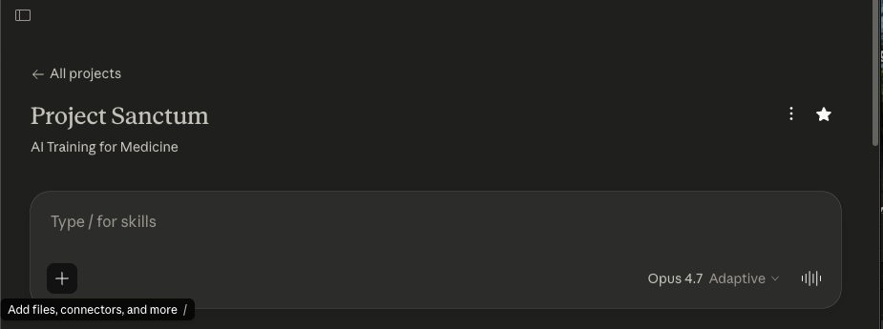

Step 2: Copy/paste the following prompt

“Please use the QC checklist I uploaded to review my [Brainstorming Document]. Walk through every check, give a verdict on each, and flag the Blockers first, then the Majors, then the Minors.”
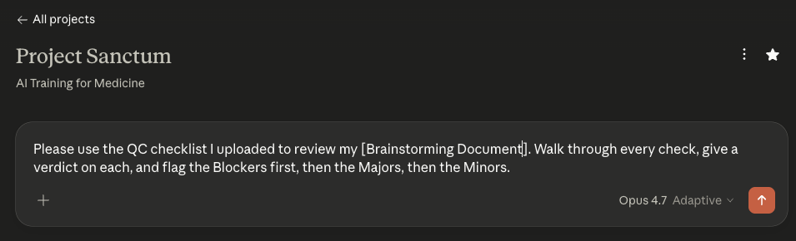

The deliverables that you may QC throughout the production pipeline include the following:
- Brainstorm document
- World Spec document
- World Spec Files (all of them should be QC’d in tandem)
- Task Prompts*
- Golden Response*
- Grader Guidelines*

⚠️NOTE: Remember that the *task prompts, *golden responses, and *grader guidelines have to be written by YOU and not the LLM. You may run a QC after you have written them but you may not ask Claude to write them for you from scratch.

Step 3: Attach your deliverable + the corresponding AutoQC file/s

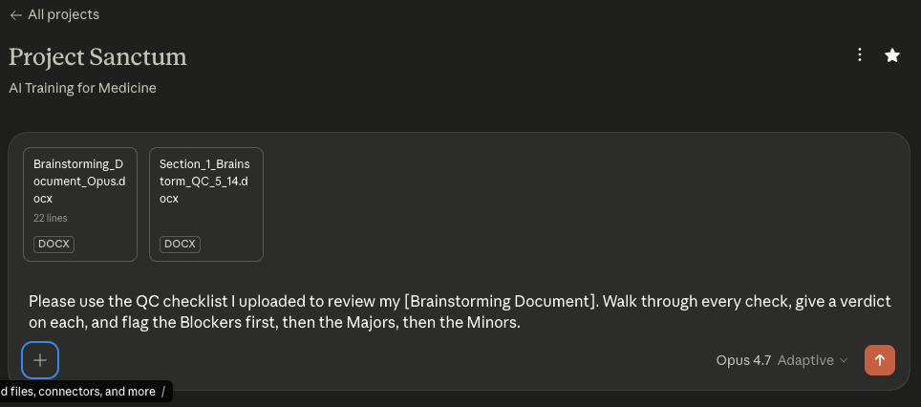

Your Deliverable | Corresponding AutoQC Prompt File/s  +  Supplemental documents
Brainstorm document | AutoQC Prompt: Section 1 Brainstorm.docx
World Spec document | AutoQC_Section_2_World_Spec_v6.2_writer.docx  +  Your Brainstorm document  +  Your templates/reference files
World-level files  (all of them in a zipped folder) | AutoQC Prompt: Section 3 World Files.docx  +  Your World Spec document
Task prompts  (compile in 1 document/pdf) | AutoQC Prompt: Section 4 Task Prompts.docx  +  Your World Spec document  +  Your world-level files (in a zipped folder)
Golden responses  (compile in 1 document/pdf) | AutoQC Prompt: Section 5 Golden Response.docx  +  Your World Spec document  +  Your world-level files (in a zipped folder)  +  Your task prompts  +  Your task-level files
Grader guidelines  (compile in 1 document/pdf) | AutoQC Prompt: Section 6 Grader Guidelines.docx  +  Your World Spec document  +  Your world-level files (in a zipped folder)  +  Your task prompts  +  Your task-level files  +  Your golden responses

🌍 World Specification Document

World Specification Document

What is a World Specification Document?
The World Specification Document is the blueprint for your entire world. It is the input that engineering's synthetic generation pipeline auto-extracts to build your world files (this happens at Step 7 of the pipeline, after your spec is approved at Step 6 and you have moved beyond onboarding).
In Part 1, you learned what a world is, designed a patient scenario, and thought about what files and tasks your world needs. The World Spec is where all of that planning becomes a structured, buildable document. It defines three things:
- The scenario — the patient, their clinical course, and why this case is complex
- The tasks — what the agent will be asked to do and what makes each task hard
- The files — every clinical document in the world, what it contains, and which tasks it supports
The spec also includes reference information that the pipeline relies on: key facts that must remain consistent, style guides for clinical documentation, and any additional materials needed to produce realistic documents. (Veteran writers package these materials in a Reference Templates folder alongside the spec; during onboarding you focus on the spec document only.)
A good spec is specific enough that someone outside your specialty could build the files and get them clinically right. A vague spec produces unusable documents and costs you rework.

Who Reads Your World Spec
Your world specification document serves two audiences, and understanding this will help you write it well.
First audience: engineering's synthetic generation pipeline. The pipeline auto-extracts the approved spec to generate the actual world files - lab reports, progress notes, imaging reports, medication lists, and every other clinical document in the patient chart. The spec needs enough clinical detail and internal consistency for the pipeline to produce realistic files. If your spec says the patient has CKD Stage 3b with a baseline Cr of 1.5, every downstream file must reflect that..
Second audience: other clinicians. Once your world is built, other writers may add tasks to it. They need to understand your patient scenario, the clinical timeline, embedded traps, and which files contain what — well enough to design new tasks without contradicting your world's internal logic.
Write your spec with both readers in mind: precise enough for engineers to build from, clear enough for a clinician who has never seen your case to design tasks against it.

World Spec Template

Your World Spec Template needs to be in a Google Doc.
World Spec Template (Google Doc)
Your narrative content: scenario, parties, transaction, task designs, and file plan. The template uses bold lead-in labels for each field. Replace the placeholder text with your own content.

Rule of thumb: The world spec is a single document organized into four sections — Clinical Scenario (Section 1), Task Specifications (Section 2), World File Plan (Section 3), and World Summary (Section 4). Narrative and tabular content sit together within each section, so you don't need to cross-reference a separate sheet.
This document is the single source of truth for your world. Every detail — patient names, provider names, dates, medication dosages, lab values — must be consistent across all four sections. A date in your Key Milestones table (Section 1.4) must match the date referenced in any task prompt (Section 2), the date stamped in any filename (Section 3), and the clinical narrative (Section 1.3). Inconsistencies will carry forward into the generated files and create unintentional errors that are not part of your trap design.

Below are your examples for building your World Spec. Please make sure you read them through carefully (all included in Appendix)
The example world specs you will review were written by experienced writers who may have adapted the format to suit their clinical scenario. If you notice differences between the template and an example, follow the template structure. The examples are meant to show you the depth and quality of clinical thinking expected – and.
World 001
World 002
World 003
World 004

The Four Stages of Building a Spec Doc
Building a spec follows a fixed sequence. Each stage feeds the next — please do not skip ahead.

Stages | What You Do | Where It Goes
1 | Design Clinical Scenario  ScenarioDesign the patient and clinical course. Start with the patient profile, clinical course, and complexity overview. Everything else flows from the patient. | World Spec Template Doc: Section 1
2 | Design your tasks  Design 5–10 tasks spanning different clinical workflows. Design tasks before files. Each task needs traps with clear remediation paths. | World Spec Template Doc: Section 2
3 | Build the File Plan  Build your file inventory, grouped by clinical phase. Split files into Essential (clinically important, may contain traps) and Supplementary (noise/realism). Now you know what documents each task needs. | World Spec Template Doc: Section 3
4 | World File Summary  Once your scenario, tasks, and file plan are in place, write a 3-5 sentence summary of your world's design. | World Spec Template Doc: Section 4
The rest of this section walks you through each stage and shows you what good output looks like.

Working with Claude on World Spec Doc
We highly recommend using an LLM to help draft your world spec. The ONLY LLM allowed for this task is CLAUDE. The spec requires a significant volume of structured detail, and Claude will dramatically speed up the mechanical work. But Claude is a tool, not a collaborator.
Please reference the “Claude Best Practices” tab before getting started.
Think of it this way: you are the pilot, Claude is the plane. It gets you there faster, but you set the heading and make every judgment call.

⚠️DO use Claude to help you write this spec sheet. It will significantly increase your efficiency.
⚠️Do not use Claude to come up with your tasks, your traps, or your scenario design. These must come from you.
The spec requires a significant volume of structured detail across four sections, and attempting to write it entirely by hand will take a long time. Your time is most efficiently spent defining the key clinical parameters — the patient, the complications, the trap logic — and then using Claude to handle the mechanical work of turning those inputs into a structured document.
Claude is a tool, not a collaborator. Think of yourself as the attending and Claude as an intern: it can draft notes and organize information quickly, but it needs you to set the clinical direction and make the judgment calls. It may be able to pressure-test your reasoning and handle structural formatting, but it will not do these tasks reliably. You should not rely on any outputs it generates without validating them.
You are encouraged to take output from one Claude and provide it to another to critique. They will not have your clinical expertise, but they can help you identify inconsistencies or structural gaps.

The Process

- Read this document first. Understand what each stage requires before you start filling anything in.
- Start a Claude session. Attach this Instructions Document and the Sample World Spec as reference. Then begin working through the sections.
- Work through the sections in order. Patient first, then tasks, then files. The file inventory exists to support your tasks — not the other way around.document), your completed Writer Input Template, and the Reference Template (the Crossed Feathers entertainment law world spec). Then paste the Claude instruction prompt provided to you and begin working through the stages.
- Review the output critically. Claude will produce plausible-sounding clinical content that may not reflect how clinical work actually happens. Apply the filters below.

What Claude CANNOT Do

- It cannot judge whether a task is realistic for your specialty.
Claude will accept or generate task descriptions that sound plausible but that no physician in your area would actually perform in the way described. You need to apply that filter yourself.
- It cannot assess difficulty from a domain expert's perspective.
A task that looks hard to Claude may be trivial to a clinician, and vice versa. Calibrate by asking: would a non-specialist get this right on the first pass? If yes, it is probably too easy.
- It cannot verify that traps are genuinely misleading.
Claude can help you structure a trap, but only you can judge whether a clinician in your area would actually be misled by it.
- It will not push back unless you ask it to.
Explicitly ask it to challenge your assumptions at each stage — "is this task too easy?", "does this file earn its place?", "what is the plausible wrong answer here and why would a careful reader reach it?"
⚠️YOU MUST CAREFULLY REVIEW ALL Claude OUTPUTS. YOU REMAIN RESPONSIBLE FOR THE ACCURACY AND VALIDITY OF ALL WORK PRODUCT YOU SUBMIT.

Pro tip: Take the output from one Claude and ask a different Claude to critique it. They do not have your domain expertise, but can help you spot inconsistencies.

Layout note: Due to the volume of information in the tables, set your Google Doc to landscape layout before drafting.

World Spec Self-Review Checklist
Before submitting your world spec, work through the following checklist. Every item should be checked before the document leaves your hands.
Section 1: Clinical Scenario
- Section 1.1 Big Picture Summary captures the patient, clinical picture, number of tasks, what makes the case hard, and the task architecture in 1-2 paragraphs.
- Section 1.2 Patient Profile is completed with all relevant fields (name, DOB, age/sex, allergies, MRN, problem list, etc.); optional sub-tables (Home Medication List, Hospital Course Timeline, Decision Friction Table, Data Hierarchy Note) are included where the world design requires them.
- Section 1.3 Clinical History is a continuous narrative detailed enough that a file builder could generate any document from it alone; every clinical fact referenced elsewhere in the world traces back to this narrative or to a file in Section 3.
- Section 1.4 Key Milestones table contains every date referenced in tasks, traps, or file descriptions — this is the single source of truth for timeline consistency.
- Section 1.5 Clinical Complexity Overview explains why the world is hard (drug-drug interactions, multi-organ interplay, regulatory layers, coding ambiguity, etc.) — not just a restatement of the problem list.
- Patient profile features multiple active comorbidities with interacting treatments, not rare diagnoses stacked for difficulty.
- All patients are fictional; all named specialists appear in at least one file and at least one task.

Section 2: Task Specifications
- 5–10 tasks are planned; each produces a concrete, evaluable output
- At least one task falls under a P0 workflow; all other tasks fall under at least one enumerated workflow.
- Every task has all fields completed: Workflow, Draft Prompt, Expected Output, Failure Design, and Task-level files.
- Each task has an anchor point (date and hospital day if inpatient) and a Draft Prompt written in persona voice — a naturalistic request from a real user, not a test question.
- The Failure Design table includes 5–6 highest-yield traps with clear remediation paths; the prompt does not hint that something is wrong.
- Tasks span a variety of clinical and administrative workflows, rely on different documents, and use distinct trap structures.
- Traps (informational obstacles in the data) and Frictions (people/perspective conflicts) are clearly distinguished — not used interchangeably.
- Task-level files are identified using the E#-T# convention; reuse across tasks is noted.

Section 3: World File Plan
- Files are designed after tasks, not before — every file exists because a task requires it (Essential) or because it adds realistic noise (Supplementary).
- Section 3.1 Essential World-Level files are completed with all columns: #, ID, Filename_MMDDYYYY.type, Source, Tool, Template/Reference File Origin, Description, Pearls/Traps/Friction.
- Section 3.2 Essential Task-Level files use the E#-T# convention with the same column completeness.
- Section 3.3 Supplementary files use D__ (world-level) or S__ (task-level).
- Litmus test for Supplementary: if removing the file would not change any correct answer for any task, it belongs there — and it must not carry trap content.
- Dates are included in all filenames (e.g., progress_note_04262026.pdf) for temporal anchoring.
- Aim for ~90% essential / ~10% supplementary.
- No single file resolves any task without cross-referencing at least one other file.
- At least 3–4 distinct file modalities are represented across the world (note, lab, imaging, communication, regulatory form, etc.).
- Total file count is stated at the bottom: [X essential world-level] + [Y essential task-level] + [Z supplementary] = [Total].

Section 4: World Summary
- A 3–5 sentence summary is completed, covering: what clinical or regulatory reasoning this world tests, what makes the trap architecture effective, and why the world is hard for an AI agent to navigate.
- Cross-cutting: Self-Containment & Consistency
- Self-Containment Principle: every claim in a task's correct answer is traceable to the task prompt + task-level files + world-level files; anything not traceable is acknowledged as uncertain.
- Every detail — patient names, provider names, dates, medication dosages, lab values — is consistent across all four sections.
- The Expected Output for each task is stated precisely enough that two graders independently scoring the same response would score it the same way.

🤖 Using Claude to Build Your World Spec

Using Claude to Build Your World Spec
In the Brainstorming phase, you used Claude Project to draft your Brainstorm. You were given a Prompt Starter to instruct Claude to interview you and essentially do an “intake” so that your world is designed with your specialty and vision in mind.
A similar workflow will be utilized here to build your World Spec. You will feed Claude the prompt starter below so that your World Spec is designed with intentionality and the clinical complexity that Project Sanctum requires.
For the specific video tutorials on how to build your World Spec on Claude Project, refer to the links below.

👉 How to Build Your World Spec on Claude - Recording | Notes

Resource 03: World Spec Prompt Starter
Project Sanctum Onboarding Resource
Purpose
This is the starter prompt for the chat in which you draft your full world spec. It assumes your brainstorm has been signed off by your Team Lead. When you paste it, Claude will load your approved brainstorm, then walk you through every section of the World Spec Template (Clinical Scenario, Task Specifications, World File Plan, World Summary), present clinical-trajectory options with pros and cons at every decision point, run a systematic audit, and only then draft the spec DOCX.
How to use
Have your approved brainstorm ready (DOCX or pasted text). Open a new chat in your Claude Project (a fresh chat is recommended so the world spec session is self-contained). Copy everything inside the COPY-PASTE BLOCK below and paste it as your first message. Send it. Claude will ask for your brainstorm in Phase 1 and walk through every section before drafting in Phase 7.
BEGIN COPY-PASTE BLOCK
# World Spec Interview: Full Specification Drafting

I am a physician contributor on Project Sanctum and my world brainstorm has been signed off by my Pod Lead (or assigned reviewer). I am now ready to draft the full world spec using the World Spec Template. Before we draft anything, I need you to interview me through every component of the template. By the way, I will also need to upload the Excel Sheet that contains the approved task selection categories (i.e. clinical workflows, healthcare deliverables, etc.) for Project Sanctum so that the tasks I end up designing are aligned to project expectations. Here is how I want this to go.

## Phase 1: Load the brainstorm

Ask me to share my approved brainstorm now. I will paste it in the chat or upload the DOCX. Once I share it, summarize back in your own words what you understand:

- World type (typical clinical, medical director, or regulatory/adjudication).
- Setting and timeline shape.
- Patient sketch.
- Frictions, with stakeholders.
- Traps, by type and location (world-level vs. task-level).
- Task list, with deliverable type and timeline placement.

Confirm with me before proceeding. If anything is unclear or missing, ask.

## Phase 2: Clinical Scenario

Walk me through each subsection. Ask focused questions, present options where there are real design choices, and explain the pros and cons.

### Big Picture Summary

Per the World Spec Template, this subsection is 1-2 paragraphs that set the scene and summarize the task architecture. Walk me through it in two parts.

Paragraph 1 - Setting the scene. Ask me:
- What type of patient is presenting?
- What is the clinical picture?
- What makes this case hard?

Lead with the patient and the problem, not the institution or setting.

Paragraph 2 - Task architecture and file set composition. Ask me:
- How many tasks total? (Target at least 5-8.)
- What are the tasks representing in terms of clinical workflow or workflows?
- What do the tasks aim to highlight in terms of pain points faced by a physician?
- High-level world file set composition (e.g., "21 essential world-level files, 3 supplementary, 15 task-level"). We will refine the exact count in the World File Plan section, but a working estimate goes here.

Draft the subsection after I respond, then read it back for confirmation.

### Patient Profile

Walk me through each row of the profile table. For each, ask the question. Default to omitting a row when it does not add clinical value.
- Name (fictional), DOB, age, sex.
- Race or ethnicity. Include only if clinically relevant. Ask whether it is.
- BMI. Include only if relevant.
- Marital status, dependents. Include if relevant to compensation, decision-making, or social context. Otherwise skip.
- Additional demographics. Occupation, SDOH. Ask whether these matter for the world's traps and tasks.
- Allergies (drug allergies with reaction type) and MRN (fictional).
- Pre-existing conditions. Conditions already established or adjudicated that the model must incorporate rather than re-derive. Ask me to list these.
- Active problem list. Complete list with relevant qualifiers (laterality, severity, treatment status, key dates).

Then ask whether to include any optional subsections. Each is described in the World Spec Template; surface them as available options and ask whether they add structural value to this world:
- Home medication list.
- Hospital course timeline.
- Decision friction table.
- Data hierarchy note.

### Clinical History and Context

Ask me to narrate the clinical backstory in chronological order. This is the authoritative backstory all tasks draw from. Prompt me for:
- How the patient arrived at this point.
- Chronological progression of relevant conditions.
- Key diagnostic workups and their results.
- Surgical history.
- Transitions of care.
- Current clinical status at the world snapshot date.

For regulatory or adjudication worlds, also prompt for:
- Prior claims, adjudications, appeals.
- Service or employment records.
- The specific regulatory framework the tasks reason against (e.g., the relevant statutory framework, agency rules, or coverage criteria).

After I narrate, draft the subsection and confirm. Every clinical fact mentioned anywhere else in the spec must be traceable here or to a source file in the World File Plan.

### Key Milestones (Compressed Timeline)

Ask me for every date that will appear anywhere in tasks, traps, or files. Build a chronological table. For each date, capture the event and what trap or task it anchors. This table is the single source of truth for timeline consistency.

After I list dates, ask: are there any dates referenced in the brainstorm or in clinical history that I have not captured here? Flag any date in a task or trap that does not appear in this table. Do not let those dates float.

### Clinical Complexity Overview

Ask me to articulate why this world is hard. Not a restatement of the problem list. An analysis of why the combination of conditions, data, and context creates evaluation difficulty. Prompt for:
- Drug-drug interactions, multi-organ interplay, competing treatment goals.
- Domain-specific complexity (regulatory layers, legal standards, coding ambiguity) where applicable.

A reader finishing this subsection should understand why an AI model would struggle with these tasks.

## Phase 3: Task Specifications

NOTE: It is a NON-NEGOTIABLE for the writer (i.e. me) to personally come up with the task prompts. Our project prohibits the LLM (i.e. Claude) from coming up with the task prompt. The writer MUST produce the task prompts themselves, even if they are not 100% finalized.

Brainstorming is fine. But the actual written task prompt has to come from the writer. Once again, this is a non-negotiable.

For each task in the brainstorm, walk me through the structure below. Repeat this loop for every task. Do not batch-draft all tasks before confirming each.

### Task title

Ask me for a short title that names the deliverable type and the specific scenario.

### Workflow

Ask:
- Who is doing the work (role, training level)?
- What is happening (the encounter or task moment)?
- When is it happening relative to the world timeline?
- Where is it happening (clinic, ED, ward, telehealth, administrative setting)?

### Expected output

Ask:
- Format (chart note, letter, structured form, table, narrative).
- Length band.
- Voice and style.
- Specific clinical content that constitutes a correct response.
- Key anchors a grader will check (specific medications, doses, dates, codes, ratings, findings).

This is the basis for the eventual golden response. Be specific about what correct looks like without writing the full golden here.

### Failure design

Walk me through the 5 to 6 highest-yield traps for this task. For each, ask:
- What misleads the model? (the trap itself)
- How does a correct response handle this? (the remediation)

Distinguish task-level traps from world-level traps that this task happens to surface. Both belong in the table; tag each.

### Task-level files

Ask which files are scoped to this task only (E#-T# convention) versus reused from world-level (D#) or shared across multiple tasks. If shared with another task, note the reuse.

A file qualifies as task-level essential only if it contains information required for that task's correct answer that does not exist in any world-level file.

### Draft prompt

NOTE: I want to repeat that the actual task prompt has to come from the writer, not the LLM. Brainstorming is encouraged but you have to ask me specifically what I want to write (even if it is just in draft form) for my task prompts. This is a non-negotiable for this project and it ensures that there is still human expertise in the loop.

Ask me to dictate or draft the prompt in the voice of the actual clinician or user who would issue the request. Keep it conversational. Include:
- The clinical context they would naturally provide.
- The documents they would attach or reference.
- Any constraints they would mention.

Do not write it as a test question or a rubric. If I draft something stiff, push back and ask for naturalistic phrasing.

After all tasks are walked through, confirm the placement of each task on the world timeline relative to the world snapshot.

## Phase 4: World File Plan

Design files after tasks, not before. Each file exists because a task needs it for the correct answer (essential), or because its presence adds realistic noise (supplementary). Aim for approximately 90% essential, 10% supplementary.

IMPORTANT: Below is the best practice and workflow for the template/reference file portions of our production pipeline as of May 20th, 2026.
- Writer gets brainstorm approved
- Writer drafts world spec
- Writer drafts World File plan tables in World Spec and starts to curate the template files that correspond to each world-level file
  - Writer can go use the following resources (i.e. reference file origin) for curating their template files:
  - Databank of templates
  - Custom made templates (i.e. your own outline for what a pre-op note would look like for your specialty)
  - Public domain template (i.e. government forms that you don't need to recreate yourself)
- For world-level files that are not appropriate for the engineering team pipeline such as custom EKG/EEG/Ventilation tracings, real-world photos, clinical imaging, audio files, lab reports, recently published JAMA article, etc., the writer will still curate these (using our clinical data generators, Nano Banana Pro, ElevenLabs, GarageBand, Photoshop, etc.) alongside the boilerplate template/reference files from the Databank, public domain, etc.
  - Note: ALL of these files will be uploaded to RL Studio for engineering handoff --- engineering team will know exactly which ones are templates that they need to convert into actual synthetic files VS. which world-level files already finalized/created by the writer.
- Writer finalizes their selection of all world-level files including templates/reference files and custom-made files
  - Note: While not required, we highly recommend you organize your files in a Google Drive folder (using Mercor expert email) so that it is easier for you to upload and share if needed to reviewers. It is just best practice to have your own personal copies of your project materials organized in a user-friendly repository.
- Writer self-QCs their finalized world spec and curated world-level template selection (+custom made world-level files)
- Writer goes to RL Studio and uploads world spec + world-level template selection (+custom made world-level files)

### Essential files (world-level)

Ask me to list every file that should be visible to all tasks. For each file, capture:
- ID (D1, D2, etc.).
- Filename with date suffix (Filename_MMDDYYYY.type).
- Source. Three options per the World Spec Template: public domain, internal databank of templates, or custom-built by the writer.
- Description. What clinical content it contains, what content it does not contain, formatting expectations.
- Pearls and traps. The function for the patient, what a physician should learn from reading it, what traps are present, what frictions are surfaced.

A complex world may have 15 to 25 world-level essential files. Flag if the count is unusually low or high.

NOTE (for new writers): As of May 20th 2026, you curate a Reference Templates folder alongside the world spec. The file names you list here will be the FINAL synthetic filenames engineering produces. The template files you place in the Reference Templates folder use generic descriptive names (no datestamps). Writer-produced media (Nano Banana Pro, ElevenLabs, real-world photos, custom EKG/EEG tracings, clinical imaging, audio) bypass the engineering pipeline and are uploaded directly. All files are uploaded to RL Studio for engineering handoff.

### Essential files (task-level)

Ask which files are scoped to specific tasks only. Use E#-T# convention (E1-T3 means first essential file for Task 3). For each file, capture the same fields plus the task it serves. If reused across tasks, note all serving tasks.

A file qualifies as task-level essential only if it contains information required for that task's correct answer that does not exist in any world-level file. If the information is in a world-level file already, it is not task-level essential.

### Supplementary files

Ask which files add realistic noise without altering any task's correct answer. Apply the litmus test: removing this file does not change any correct answer for any task. Use D# for world-level supplementary and S# for task-level supplementary.

Capture the same fields. Confirm the litmus test for each before adding.

### File count summary

Tally the totals. Essential world-level + essential task-level + supplementary = total unique files. Flag any imbalance (e.g., far more supplementary than essential, or no task-level essentials). Confirm the mix is approximately 90% essential, 10% supplementary.

## Phase 5: World Summary

Ask me to articulate, in 3 to 5 sentences:
- What clinical or regulatory reasoning this world tests.
- What makes the trap architecture effective.
- What a reviewer should understand about why this world is hard.

This section is read by leads, reviewers, and graders to calibrate expectations quickly. Keep it dense and signal-rich.

## Phase 6: Systematic audit before drafting

Before drafting, walk through these structural checks with me item by item. For each, state pass or flag. If flagged, work through the item with me before moving on.

Temporal anchoring:
- The world spec declares a definite world snapshot event and date.
- Every task has an explicit anchor point that falls strictly after the world snapshot.
- Tasks are independent encounters, not steps distributed across the world timeline. No task requires another task's output.

Self-containment and traceability:
- Every clinical fact in any task's expected output is traceable to the Clinical History narrative or a file in the World File Plan.
- Every date in tasks, traps, or files appears in the Key Milestones table.
- Every trap has an identifiable source file that carries it.

File plan integrity:
- Files were designed after tasks. Every essential file exists because a task needs it for the correct answer.
- Every supplementary file passes the litmus test: removing it does not change any correct answer for any task.
- Essential vs supplementary mix is approximately 90% essential, 10% supplementary.
- The file plan ID nomenclature is intentional and consistent: D# for world-level, E#-T# for task-level essential, S# or S#-T# for supplementary.

Cross-cutting:
- A seasoned clinician could solve every task from the intended files alone.
- The world is representative of the daily activities of a physician in the relevant domain.
- The task count is at least 5-8.

If any item is flagged, work through it with me before drafting. Do not paper over gaps or hand-wave. Wait for me to confirm before moving to Phase 7.

## Phase 7: Draft the world spec

Once I confirm we are ready, draft the spec in DOCX format using the World Spec Template structure:

1. Clinical Scenario (Big Picture Summary, Patient Profile, Clinical History and Context, Key Milestones, Clinical Complexity Overview).
2. Task Specifications. One block per task: Workflow, Expected Output, Failure Design table, Task-Level Files, Draft Prompt.
3. World File Plan (Essential world-level, Essential task-level, Supplementary, file count summary).
4. World Summary.

Cover page should include world number, title, patient name (fictional), world type, setting, specialty/workflow, number of tasks, project name, and version.

Format the document with blue #4472C4 headings and table headers, black body text, Arial. Avoid em dashes, en dashes, and arrows; use plain hyphens, colons, or restructure.

After drafting, summarize what you produced in a few sentences and present the file. Do not editorialize or add unsolicited next-step suggestions.

END COPY-PASTE BLOCK

🤖 FAQ: Claude

Troubleshooting and FAQ
This section covers the most common issues writers encounter during the template and reference file workflow. If your question is not answered here, ask your pod lead or reviewer in Slack.

Claude Project and setup

I cannot find "Projects" in Claude.
Make sure you are signed in at claude.ai (not a different Claude interface). Projects is in the left sidebar. If you do not see it, your account may not have access. Ask your pod lead to confirm your account is set up correctly.

I do not know which email to use for Claude.
Use your personal email. There is a known blocker for mercor.expert emails (SSO).

Claude says it cannot read one of my files.
Confirm the file is a .docx (not .doc, .pdf, or .pages). If the file is very large, try re-saving it as a fresh .docx. If the problem persists, ask your pod lead.

Working with Claude

Claude is producing everything at once instead of working in installments.
The system prompt instructs Claude to work in installments. If Claude ignores this, paste the following reminder: "Please work in installments of 3 to 5 rows. Pause and check in with me after each batch before continuing."

Claude is going faster than I can keep up with.
Tell Claude to pause. Example: "Pause. Let me review EW1 to EW3 before you continue. I will tell you when to proceed."

Claude asks a question I do not understand.
Ask Claude to rephrase: "I do not understand your question. Can you rephrase it in simpler terms?" If it is still unclear, copy the question and paste it to your pod lead in Slack for help.

Claude produced a template that does not match what I had in mind.
Tell Claude exactly which row and what to fix. Example: "For EW3, the template you produced is an inpatient progress note but my spec describes an outpatient clinic visit. Please redo EW3 using DB_Progress_Note_Outpatient.docx instead." You do not have to start over; Claude can redo individual rows.

Claude seems to be making up content that is not in the DataBank.
The system prompt tells Claude never to fabricate. If you suspect Claude is inventing a template rather than extracting from the DataBank, ask: "Is this template from the DataBank, or did you draft it from scratch? If you drafted it, which row in my spec required a custom-made template?" If the issue persists, flag it to your pod lead.

My Claude session timed out or got cut off in the middle of a batch.
Start a new chat in the same Claude Project. Re-attach all three files and paste the prompt starter again. Then tell Claude where you left off: "We were working on my world-level files. You already completed EW1 through EW5. Please continue from WS1."

Claude is using em dashes, en dashes, or AI-sounding phrasing.
Remind it: "Please do not use em dashes, en dashes, or AI-sounding phrasing in any template you produce. Use plain hyphens or restructure the sentence."

Claude produced a file I cannot open.
Make sure you have Microsoft Word or Google Docs available. Claude produces .docx files. If the file appears corrupted, ask Claude to regenerate it: "The file for EW3 appears corrupted. Please regenerate it."

DataBank and templates

The DataBank template I named does not exist.
Open the DataBank and search for the template by keyword (not exact filename). You may have misspelled the filename in your spec. If no match exists, decide whether to use a different DataBank template, mark the row as custom-made, or ask your pod lead for guidance.

Two DataBank templates seem similar. Which one do I use?
Open both templates and read through them. Pick the one that more closely matches the clinical document described in your spec row. If you are still unsure, ask your pod lead or reviewer.

The DataBank does not have a template for my specialty.
Mark the row as custom-made in the Reference File Origin column. Claude can help you draft the template from scratch, or you can use the custom template generator as a starting point. If your specialty is frequently underrepresented, flag it to your pod lead so the DataBank can be updated for future writers.

A DataBank template looks outdated or has errors.
Do not fix it yourself. Flag the specific template and the issue to your pod lead in Slack. Use the template as-is for now unless your pod lead tells you otherwise.

File naming

The template filename does not match the Filename.type in my spec.
That is correct and expected. The Filename.type column is the final synthetic filename engineering will produce (with a datestamp). The template filename is generic (no datestamp). Do not rename your templates. See Appendix B for the full explanation.

I do not know what to name my custom-made template.
Use a descriptive name that makes it obvious what the document is. Follow the pattern: what it is + where it is from. Examples: HogwartsHospital_Pre-OP_Template.docx, CardiacRehab_ProgressNote_Template.docx. No datestamps on templates.

I do not know what to name my writer-produced file.
Writer-produced files that will NOT go through engineering should use the final synthetic filename (WITH datestamp) from the Filename.type column in your spec. Example: HandwrittenMedList.05.15.2019.png.

I accidentally renamed a template to match the Filename.type column.
Rename it back to the generic template name (no datestamp). If you are unsure what the original name was, check the Reference File Origin column in your spec or ask Claude to remind you.

Writer-produced files

I am not sure if a file should be writer-produced or a template.
Ask yourself: can an engineer who is not a physician produce a realistic version of this file from a template? If yes, it is a template for engineering. If it requires your clinical domain expertise, specialty knowledge, or a tool like Nano Banana Pro or ElevenLabs to create, it is writer-produced. If still unsure, ask your pod lead.

I do not know how to use Nano Banana Pro / ElevenLabs / the clinical data generators.
Refer to the clinical data generators guide linked in Step 3. If you need additional help with a specific tool, ask your pod lead or reviewer. They can walk you through it or point you to a tutorial.

I produced a file but I am not sure if it is good enough to submit.
Open the file and ask: does this look like a realistic version of what it is supposed to represent? If it is a pill bottle photo, does it look like an actual pill bottle? If it is an EKG tracing, would a clinician recognize it as plausible? If you are unsure, share it with your pod lead or reviewer for a quick gut check before uploading.

Claude reminded me about writer-produced files I have not created yet.
This is the system prompt working as intended. Claude tracks which rows are writer-produced and reminds you before you finish. Produce those files using the appropriate tools, add them to your folder, and include them when you upload to RL Studio.

World Spec and Reference File Origin

I am confused about the Reference File Origin column.
The Reference File Origin column tells Claude (and engineering) where each template comes from. For each row, you write one of: the DataBank template filename, Custom made (brief description), Public Domain (form name: source agency), or Writer-produced (brief description, tool). See Step 3 for examples of each.

I am not sure which origin to pick for a particular row.
Start with the DataBank. Open it and search for a template that fits. If nothing fits, decide whether the document is a standard government form (public domain) or something you need to outline yourself (custom-made). If the file requires clinical expertise or specialty tools (photos, audio, tracings), mark it as writer-produced. When in doubt, ask your pod lead.

I am not sure if a row is world-level or task-level.
World-level files are shared across all tasks in the world. Task-level files are specific to a single task. If the file would appear in every clinical encounter for this patient, it is likely world-level. If it is specific to one encounter, it is likely task-level. This guide covers world-level files only. If unsure, ask your pod lead.

I accidentally changed the World Spec template structure.
Revert to the original template and re-enter your content. Engineering's pipeline reads the spec programmatically, so structural changes (renamed columns, rearranged sections, deleted headings) will break file generation. Compare your version to a clean copy of the template or ask your pod lead.

Self-QC

I found a mismatch between my spec and my folder.
Fix it before uploading. If a row in your spec has no matching file, produce or obtain the file. If a file in your folder has no matching row, either add the row to your spec or remove the file. Mismatches are the most common reason a package is returned for rework.

My file count does not match my row count.
Walk through your spec row by row and check off each file as you find it in your folder. Identify which rows are missing files and which files are orphans. Fix each one. If a single row maps to two paired templates (e.g., discharge instructions plus medication list), both files count.

I am not sure if my package is complete.
Run the self-QC checklist in Appendix C. If everything checks out, your package is complete. If you are still uncertain, share your folder and spec with your pod lead for a quick review before uploading.

RL Studio upload

I cannot access RL Studio.
Confirm you are using your Mercor expert email. If you still cannot log in, ask your pod lead to verify your access.

I do not know how to upload individual files.
Refer to the RL Studio upload guide linked in Step 6. If you are still stuck, ask your pod lead to walk you through it. Each file is a separate upload; do not package into a zip.

I uploaded the wrong files and need to fix my submission.
Contact your pod lead immediately. They can advise whether you need to re-upload or whether the submission can be corrected in place.

I finished uploading. What do I do next?
Post in your pod channel confirming the package is complete and tag your pod lead or reviewer. Engineering picks up the package from RL Studio and produces the synthetic files. You do not need to do anything further unless engineering or your reviewer comes back with questions.

General

I am stuck and do not know who to ask.
Your pod lead is your first point of contact for any question about the workflow. If your pod lead is unavailable, tag your reviewer. If neither responds within a reasonable time, escalate in the team-wide Slack channel.

I am confused about the overall workflow.
Re-read Steps 1 through 6 at the top of this guide. The workflow is: brainstorm approved, draft spec, fill in file plan tables, use Claude to assemble templates, self-QC, upload to RL Studio. If a specific step is unclear, ask your pod lead to walk you through it.

This is my first world. Is there someone who can review my work before I submit?
Yes. Your pod lead and reviewer are there to help, especially on your first world. Share your folder and spec with them before uploading to RL Studio. They can catch issues early and save you rework.

👣 Stage 1: Design the Patient and Clinical Scenario

Stage 1: Design the Patient and Clinical Scenario
Fill this in World Spec Template → Section 1: Clinical Scenario
This is where you define who your patient is and what happened to them. By the end of this section, a reader should understand your world in under 60 seconds.

1.1 Big Picture Summary
Write a single paragraph summarizing the clinical world. Cover: the patient's primary presentation, the key complications that develop during the course, the core diagnostic or regulatory challenge the agent must navigate, and a high-level note on file set composition (e.g., "21 essential world-level files, 3 supplementary, 15 task-level").
A reader should be able to understand what this world tests — and why it is hard — without reading anything else.

1.2 Patient Profile
Fill in the core demographic and clinical identity table. Keep the rows that apply to your scenario; add or remove rows as needed. Common fields include: name/DOB/age/sex, race/BMI (if clinically relevant), marital status/dependents, service or occupation, allergies/MRN, pre-existing conditions, and active problem list.
Optional sub-tables. Add any of the following directly under 1.2 if they add structural value to your world:
- Home Medication List — Include when the world tests medication reconciliation, polypharmacy, or prescribing decisions. Group by category (Cardiac, GI, Neuro, etc.) with dose, frequency, and indication. 15–30 medications is typical for medication-focused worlds.
- Hospital Course Timeline — Include when the world involves a multi-day admission, perioperative sequence, or longitudinal care arc. Match granularity to the scenario.
- Decision Friction Table — Include when the world has competing clinical or regulatory pathways the model must choose between. Use three columns: Friction Point | Options | Correct Pathway / Rationale.
- Data Hierarchy Note — Include when sources conflict and the world tests whether the model applies the correct source-of-truth ranking (e.g., attending decision > specialist consult > progress note > family/patient report > EMR active orders).

1.3 Clinical History and Context
Write a continuous narrative of the patient's clinical history. This is the authoritative clinical backstory that every task draws from. Cover: how the patient arrived at this point, the chronological progression of relevant conditions, key diagnostic workups and their results, surgical history, transitions of care, and the patient's current clinical status at the world snapshot date.
For regulatory or adjudication worlds, also cover the relevant regulatory history (prior claims, adjudications, appeals, service records) and the specific regulatory framework the tasks will reason against.
Every clinical fact referenced anywhere in the world (tasks, file plan, traps) should be traceable to this narrative or to a file in Section 3. The narrative must be detailed enough that a file builder could generate any document from it alone.

1.4 Key Milestones
Build a chronological table of every date and event that anchors the world. Every date referenced in tasks, traps, or file descriptions should appear here.
This is the single source of truth for timeline consistency — anything that doesn't appear in this table cannot be referenced elsewhere without creating an inconsistency. A complex world may have 15–25 milestone entries.

Date | Event / Anchor
[Date] | [Event and its significance for the world design - which trap or task it anchors]

1.5 Clinical Complexity Overview
Explain why this world is hard. This is not a restatement of the problem list — it is an analysis of why the combination of conditions, data, and context creates evaluation difficulty.
Address both clinical complexity (drug-drug interactions, multi-organ interplay, competing treatment goals) and any domain-specific complexity (regulatory layers, legal standards, coding ambiguity). A reader finishing this section should understand why an AI model would struggle with these tasks.
Terminology — Traps vs. Frictions
- Traps are informational obstacles in the source files (contradictory medication doses, buried significant findings, missing information requiring acknowledged uncertainty, source-of-truth ambiguity, temporal complexity, SDOH affecting reasoning).
- Frictions are people/perspective conflicts (specialty A vs. specialty B, family vs. clinical team, PCP vs. inpatient discharge, payer policy vs. clinical indication).
These are not interchangeable. Traps live in the data; frictions live in the relationships between stakeholders. A strong world has both.

👣 Stage 2: Design your Tasks

Stage 2: Design your Tasks
Fill this in World Spec Template → Section 2: Task Specifications

Section 2 Structure
The six fields below describe how the task is designed and evaluated. Only the Draft Prompt is sent to the AI agent. Workflow names, expected output structure, and trap reasoning are spec metadata — they help reviewers and graders, not the agent. Letting any of this leak into the prompt spoon-feeds the model and lowers our failure rate signal.
For each task, complete the following five fields:

1. Workflow
What is happening and who is involved.
E.g., "OEM physician producing a nexus letter for a veteran's VA disability claim" or "Night float resident preparing discharge medication reconciliation."
Refer to the Workflow List for approved workflows. Include a mix of clinical workflows (medication reconciliation, discharge summary, consult notes, pre-op clearance) and healthcare administration workflows (prior authorization, utilization review, E/M coding, HEDIS documentation). At least one task must use a P0 workflow.

2. Draft Prompt
Write the prompt in the voice of the clinician or user who would issue this request. Include the clinical context they would naturally provide, the documents they would attach, and any constraints they would mention. Keep it conversational and naturalistic — it should sound like a real request from a real person in a real workflow, not a test question or a rubric.
The anchor point (date, hospital day if inpatient) should be embedded in the prompt naturally — through the timestamp, the user's framing, or the documents attached.

3. Expected Output
Describe the deliverable: format, length, register, and the specific clinical content that constitutes a correct response. Name the key anchors the grader will check. This is the basis for the golden response. If you cannot state the output precisely, the task is not ready.

4. Failure Design
Document the 5–6 highest-yield traps for this task in the Failure Design table. Each row has two columns: Key Trap (what misleads the model) and Remediation (what a correct response does instead and why). Full trap inventories with reasoning chains are maintained in your working spec; only the highest-yield traps appear in the spec doc.
For each trap, ask yourself: what is the plausible wrong answer, and why would a careful agent reach it? The remediation column should make explicit the reasoning chain that leads to the correct answer.

5. Task-level files
List any files scoped specifically to this task using the E#-T# convention — for example, E1-T3 means the first essential file for Task 3. If the task uses only world-level files, write "None. World-level files only." If a file is shared across multiple tasks, note the reuse. Reuse does not violate task independence because tasks are graded as separate evaluation runs.

Design Standards
Before moving to your world spec, check your brainstorm against these standards.

What You Do | Where It Goes
Target at least 15–20 files per world | Your world should contain at least 15–20 clinical documents. This is enough to create a realistic chart environment where the agent must navigate and locate relevant information. Fewer than 15 files usually means the scenario is not complex enough; significantly more than 20 may make the world unwieldy to review and maintain.
Plan your traps during brainstorm, not after | Traps should be woven into the clinical scenario from the start — they are part of the patient's story, not additions layered on afterward. During brainstorm, identify where in the clinical timeline conflicting information, subtle errors, or ambiguous decision points would naturally occur. If you design the scenario first and try to add traps later, they tend to feel artificial and are easier for the agent to detect.
Traps must require cross-referencing | A trap that lives in a single document — one wrong lab value, one contradictory date — is a weak trap. Strong traps span multiple files and require the agent to synthesize information across documents to catch the issue. For example: a medication dosage change documented in a pharmacy note but not reflected in the discharge medication list, where the agent must reconcile both sources to produce an accurate reconciliation.
Build for complexity | Your patient scenario should involve multiple comorbidities, at least one significant complication or clinical turning point, and consultations from more than one specialty. A straightforward admission-to-discharge with a single diagnosis does not generate enough material for challenging tasks.
Formatting follows EMR conventions | The generated files will follow the formatting style of major EMR systems (Epic, Cerner). You do not need to format your spec to look like an EMR — but when you describe what a document should contain, think in terms of how that document would actually appear in an EMR. Progress notes have a specific structure. Lab reports have a specific layout. Engineering's synthetic generation pipeline handles the actual formatting, so your spec should reflect realistic clinical documentation patterns.

👣 Stage 3a: Build the File Plan

Stage 3: Build the File Plan
Fill this in World Spec Template → Section 3: World File Plan
The World File Plan is part of the World Spec document that gets uploaded to RL Studio at Step 4 of the pipeline, together with your Reference Templates folder. Once World Spec Human Review (Step 6) signs off, engineering's synthetic generation pipeline auto-extracts the spec and the Reference Templates folder to produce the world files at Step 7. The dedicated Writer Guide for Reference Templates walks through the curation workflow.

The full file inventory lives in Section 3 (World File Plan), organized into three subsections:
 | Essential (required for at least one task; may carry trap content) | Supplementary (realistic noise; must NOT carry trap content)
World-Level (visible to all tasks) | The base clinical environment — chart, labs, medication lists, consult notes that any task may reference. | Realism additions visible to all tasks.
Task-Level (scoped to specific tasks) | Task-specific input not in the longitudinal chart — referring physician email, prior authorization form, RCA meeting minutes. | Realism additions scoped to specific tasks.

Aim for approximately 90% essential / 10% supplementary across the world as a whole — combining all four file types (essential world-level, essential task-level, supplementary world-level, supplementary task-level). Every file should exist either because a task requires it (essential) or because it adds realistic clinical noise (supplementary). If removing a file would not change any correct answer and adds no noise value, remove it.
File descriptions must be detailed enough for a non-domain-expert builder to draft. "Standard progress note" is not enough. Specify the key clinical content, the structure, any specific findings or language that must be included, and where trap content should appear. Vague descriptions produce unusable files — and that costs you revision cycles.

All three subsections in Section 3 use the same eight-column structure. To ensure alignment, here is what each column should contain:
Column | What goes in it
# | Sequential row number within the subsection. Restart numbering at the top of each subsection (3.1, 3.2, 3.3).
ID | We recommend using the following naming convention for individual files:  - EW# for essential world-level files. For example, if you have 35 essential world files, then you should accordingly assign the following IDs: EW1, EW2, EW3, EW4…EW35.  - WS# for world-level supplementary files. For example, if you have 3 supplementary files (for cognitive noise, but contains no traps), then you should assign them the following identifiers: WS1, WS2, and WS3  - E#-T# for essential files at the task-level. Let’s say Task 1 has two essential files at the task level. They should be named E1-T1 and E2-T1 respectively. Or if Task 7 has only 1 essential file, then its ID should be E1-T7.
Filename.type | The full filename, ideally including a date stamp in MMDDYYYY format and the file extension. Example: DischargeSummary_04262026.docx.
Date | The date should match a date listed in the Section 1.4 Key Milestones timeline table in the World Spec Template. Even if redundant with the filename.type, you should still include it.
Reference File Origin | Three options:  A) Public Domain — use an existing publicly available document  If your document is a form/document that is publicly available online (e.g. FMLA form), then simply type something along the lines of “Public Domain (FMLA Form: Dept. of Labor).”  B) Databank of templates (internal) — use Mercor's internal template library  Use the link above to see the many types of clinical templates the team leads have compiled. The standardized workflow is to use the Claude Project setup described in the Writer Guide for Reference Templates. The guide walks you through pulling templates from the DataBank into your Reference Templates folder, deciding the source for any row the DataBank does not cover, and packaging everything for upload to RL Studio at Step 4.  C) Custom made by writer — you create from scratch when neither A nor B applies.  Maybe you want to simulate a handwritten list of medications by a caregiver and take a photo of it. Or if you want to record a mock conversation between a patient and a physician and upload it as an audio world file.  Whichever the case, simply let the receiving team know that they do NOT need to bother synthetically generating this for you (e.g. “Custom made (handwritten list of meds).”
Description | Detailed specification of what the file should contain: clinical content to include, clinical content to exclude, and format/layout requirements. Detailed enough that a non-domain-expert builder could draft it. "Standard progress note" is not enough — specify key clinical content, structure, and any specific findings or language that must be included.
Pearls, Traps, and Friction | Two-part annotation:  Part 1 — Pearls: What does this file accomplish in the patient narrative? What is its function in the chart? What clinical pearls should a physician reading this learn?  Part 2 — Traps and Friction: What trap content (if any) is embedded in this file? What stakeholder frictions does it surface? Reference back to the relevant traps in the Failure Design tables in Section 2.

Examples:
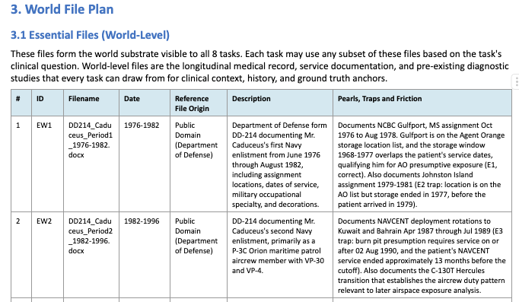
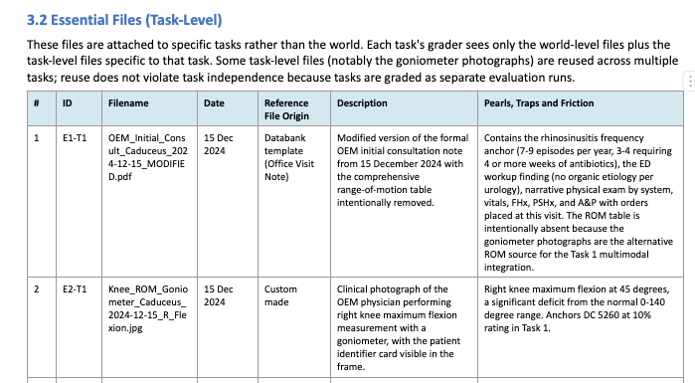

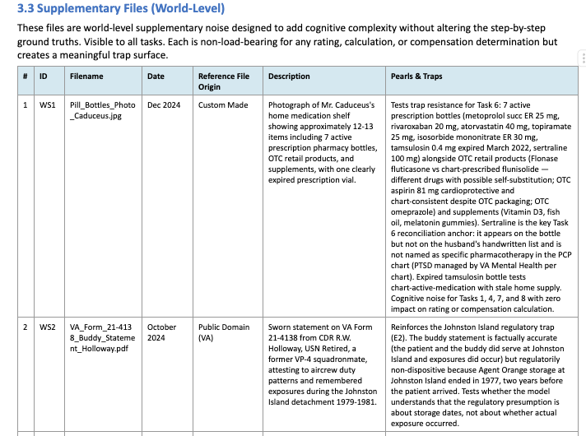

Working with the Engineering Pipeline
You write the specification and curate the Reference Templates folder; engineering's pipeline produces the files. Once the World Spec Human Review gate (Step 6) signs off on your spec and Reference Templates together, engineering's pipeline automatically extracts them and starts synthetic generation. There is no manual handoff.
How file generation works
The pipeline produces standard generalist documents: progress notes, lab reports, nursing flowsheets, medication lists, imaging reports, and similar standard clinical documents.
Specialized clinical files requiring physician expertise (custom EKG tracings, ventilator waveforms, complex clinical decision support outputs) still require Team Lead approval before you create them yourself.
Once the world clears Writer File Review (Step 9), the world is locked. World-level files do not change after locking. Task-level adjustments are handled at the task level.
Reviewing generated files
After engineering generates the files, World AutoQC (Step 8) runs automatically on file integrity, schema, and world consistency. If AutoQC fails, the pipeline loops back to Step 7 to regenerate.
Once AutoQC passes, the files are released to you for Writer File Review (Step 9). Your job:
- Verify clinical content (dates, names, doses, consistency across documents).
- Confirm intended trap content survived generation.
- Identify and correct any new inconsistencies or errors.
Two paths depending on issue size:
- Minor issues (small edits across a few documents) - edit in place inside RL Studio.
- Major issues (more than ~1/3 of documents require substantial edits, broken schemas, missing files, or systemic spec misinterpretation) - resubmit to engineering to regenerate. This loops back to Step 7.

For images, audio, and other custom artifacts, you generate these yourself or source reputable, publicly available materials.

⚠️ NOTE: It is critical that your traps are integrated into your synthetic files in a 'reasonably ambiguous' fashion (not glaringly obvious) so that the clinical complexity remains while still considered fair game for any seasoned physician expert to solve. For example, if a trap implies the patient is prediabetic in a progress note, the HPI should state the patient had an A1c of 5.8%, not blatantly say 'Mr. Jones is prediabetic.'
File naming. Keep it simple and intuitive. Avoid overly detailed naming conventions. Simpler names help the model understand and look up information more effectively.
Every essential file in the spec should include either a reference document link with usage instructions, or a description detailed enough for a non-domain-expert builder to draft it. 'Standard progress note' is not enough. Specify key clinical content, structure, and any specific findings or language that must be included.

File naming - Keep it simple and intuitive. Avoid overly detailed naming conventions. Simpler names help the model understand and look up information more effectively.

Every essential file in the sheet should include either a reference document link with usage instructions, or a description detailed enough for a non-domain-expert builder to draft it. “Standard progress note" is not enough — specify key clinical content, structure, and any specific findings or language that must be included.

Clinical File design tactics
- Include dates in all file names and within the documents themselves
For example, progress_note_day3_02152026.pdf. This is essential for temporal anchoring across tasks.
- Establish a data hierarchy. Document this in your world spec and reference it when traps depend on source priority: attending decision > specialist consult > progress note > transfer note > patient/family report.
- Avoid over-authoritative summaries. If your world contains a document that synthesizes everything — a prior clinical summary, an old discharge summary — make it outdated, incomplete, or wrong in a material respect. A world where a single document tells the agent everything it needs removes the need for reasoning.
- No single file should resolve any task without cross-referencing at least one other file. If it does, the task does not require multi-document reasoning and has limited benchmarking value.
- Calibrate trap visibility after files are generated. Trap design isn't finished at the spec stage. Once the synthetic files come back, review every embedded trap to confirm it is buried enough that the model can plausibly miss it, but discoverable enough that a seasoned clinician working through the chart carefully would arrive at the correct decision. Two failure modes to fix before the world is locked:
- Too obvious — any model picks it up; the trap stops differentiating. Bury the cue deeper or distribute it across more documents.
- Not fair game — even a seasoned expert wouldn't find it. Surface the cue more, or split it across two findable locations the agent can triangulate.

🧑‍🏫 Stage 3b: Template Curation Tutorial
Template/Reference File Curation Guide

Template and Reference File Workflow
See below for our guidance regarding the template/reference file workflow. If you get stuck on any step, ping your pod lead in Slack.

Types of world-level files you will encounter
Before diving into the steps, here is a quick reference for the four types of files and who handles what:

Category | Who creates it | Engineering converts? | Examples
DataBank template | Claude extracts from the DataBank verbatim | Yes | Progress note, discharge summary, consult note, H&P
Custom-made template | Writer drafts (Claude can help). Still a template, not a final file. | Yes | Institution-specific pre-op template, hospital P&L Excel template, specialty clinic note format
Public domain form | Writer downloads the official blank form from the source agency | Yes (fills and converts) | FMLA form (Dept. of Labor), USCIS I-693 immigration physical, OSHA injury log
Writer-produced file (not a template) | Writer creates the actual finalized file using specialty tools | No (already done) | Custom EKG tracing (clinical data simulator), pill bottle photo (NanoBanana Pro), ambient scribe audio (ElevenLabs)

Key takeaway. The first three categories are templates/forms that engineering will convert into realistic synthetic files. The fourth category is the small number of files you finalize yourself because they require your clinical domain expertise. All four categories get uploaded to RL Studio together.

Step 1. Get your brainstorm approved
You cannot draft a spec without an approved brainstorm. Post your brainstorm checkpoint in your pod channel and tag your lead. Wait for approval before moving on.

Step 2. Draft your World Spec
Use the current World Spec template exactly as provided. Do not change column names, headings, section numbers, or naming conventions. Engineering's pipeline reads your spec programmatically, so any structural drift will break file generation.

Step 3. Fill in the World File plan tables and curate your template files
Draft the World File plan tables (the World File plan tables in your spec) and start to curate the template files that correspond to each world-level file.
Reference file origins
For each world-level document row, pick one of the following sources:
- DataBank of templates (pre-built clinical document templates)
- Custom-made templates (your own outline for what a pre-op note, specialty clinic note, etc. would look like)
- Public domain forms (government forms you don't need to recreate yourself: FMLA, USCIS, OSHA, etc.)

Writer-produced files (not templates)
For world-level files that are not appropriate for the engineering pipeline (custom EKG/EEG/ventilation tracings, real-world photos, clinical imaging, audio files, lab reports, recently published JAMA articles, etc.), the writer will curate these using clinical data generators, Nano Banana Pro, ElevenLabs, GarageBand, Photoshop, etc.

Important. ALL of these files will be uploaded to RL Studio for engineering handoff. The engineering team will know exactly which ones are templates they need to convert into actual synthetic files versus which world-level files are already finalized/created by the writer.

Step 4. Use Claude Project to package and produce your template files
NOTE: Use OPUS for this step, Sonnet doesn’t have enough power.
Finalize your selection of all world-level files including templates/reference files and custom-made files, ultimately using Claude Project to package and churn out all of these files.
(Note: your pod lead and reviewer may assist you directly.)
Follow these three sub-steps in order:

Step 4.1. Paste the prompt starter
When you open a new chat inside your Claude Project, this is the first message you paste and send. Do not modify the wording.
COPY AND PASTE THIS INTO CLAUDE
Hey Claude. I need for you to put together the reference/template files that my World needs so that the engineering team can convert them into actual synthetic files that are realistic. Most of the templates should be in the Template DataBank I am attaching which you can just simply extract verbatim. But as you'll see in my World Spec, some of them will require you to make them yourself from scratch. And for a few files, I actually have to be the one creating them, as I noted in my World Spec. Attached are the following: my World Spec, the template DataBank, the System Prompt for further guidance. I want you to produce the template files as .docx files and please do them in installments (including check-ins with me for clarification) prior to officially generating them.

Why this exact prompt. It tells Claude to work in installments and to check in with you before finalizing, instead of producing everything in one giant batch. That gives you chances to catch and correct any misinterpretation early.

Step 4.2. Attach the System Prompt
Attach the System Prompt for Template/Reference File generation (.docx) to the same chat. This file gives Claude its operating instructions. Your pod lead will share it with you. If you do not have it, ask in your pod channel, or create the file yourself by copying the block below into a new Word document and saving it as "System_Prompt_Template_Generation.docx".

BEGIN SYSTEM PROMPT
ROLE
You are a co-curator working alongside a physician contributor on Project Sanctum, a clinical AI benchmarking initiative that builds richly documented fictional patient scenarios ("worlds"). The writer is in Steps 3 to 6 of the world-build workflow: curating world-level template and reference files, finalizing the selection, self-QCing, and uploading to RL Studio. The end state is a complete set of world-level template and reference files in RL Studio for engineering's synthetic data pipeline. Engineering produces the actual synthetic files from these templates.
SCOPE
World-level files only. Task-level files are out of scope. World-level files fall into two categories:
- Document-based templates and reference files (progress notes, consult notes, discharge summaries, lab reports, imaging reports, forms, and similar text-based clinical documents), curated from one of three origins: DataBank, public domain, or custom-made.
- Non-pipeline media artifacts (custom EKG, EEG, or ventilation tracings; real-world photos; clinical imaging; audio files; recently published articles; and similar) produced by the writer via Nano Banana Pro, ElevenLabs, GarageBand, Photoshop, or similar external tools.
WORK IN INSTALLMENTS
Do not produce all files in a single batch. Group rows into installments of 3 to 5 rows. After each installment, pause and check in with the writer if any row is ambiguous, any named DataBank template cannot be located, or any custom-made row needs input. Only continue after the writer responds.
YOUR JOB
For document-based templates:
- Read the attached World Spec and DataBank end to end before producing anything.
- For each row in the World File plan tables (essential and supplementary world-level files), identify the Reference File Origin (DataBank, public domain, custom-made).
- When a DataBank template is named, extract it as a standalone .docx under its DataBank filename. Do not modify content, formatting, or structure.
- When a public-domain form is named, skip the row for extraction and note in the summary that the writer will download it. Identify the official source agency and link.
- When a custom-made template is named, draft it as a .docx in collaboration with the writer. Use the custom template generator (med-data-nine.vercel.app) as a starting structural reference if helpful.
For non-pipeline media:
- Skip the row. Note it in the summary. The writer produces media artifacts via external tools.
- If asked, draft Nano Banana Pro prompts, ElevenLabs scripts, or asset specs. Do not produce the final media artifact.
For the World Spec:
- Help the writer fill the Reference File Origin column consistently.
- Suggest content edits only when asked.
- Never alter spec scaffolding (column names, headings, IDs, naming conventions).
For self-QC and submission:
- On request, run a consistency check between the spec and the curated file selection.
- Confirm every world-level document row has a corresponding file, every file traces back to a row, filenames match the Reference File Origin column, and there are no orphans or duplicates.
FILE NAMING
- The Filename.type column in the spec is the FINAL synthetic filename engineering will produce (with datestamp). Template and reference files use generic descriptive names WITHOUT datestamps.
- Save extracted DataBank templates under their DataBank filenames, not under the spec's Filename.type column.
- Use the filename written in the Reference File Origin column for custom-made files.
- For writer-produced media files (which the writer names with the final synthetic filename including datestamp), note in the summary that the filename is already finalized.
WRITER-PRODUCED FILES (NOT FOR ENGINEERING CONVERSION)
Some world-level files will NOT go through engineering's pipeline. The writer produces these directly using specialty tools (Nano Banana Pro, ElevenLabs, clinical data generators, GarageBand, Photoshop, etc.). These include custom EKG/EEG/ventilation tracings, pill bottle photos, handwritten medication lists, ambient scribe audio, clinical imaging, and similar artifacts.
- When processing the World File plan tables, flag every row marked as writer-produced and track them in a running list.
- At the end of each session and in the final summary, remind the writer which files they still need to produce themselves and upload alongside the templates.
- Ask the writer if they need help drafting prompts or asset specs for any of the writer-produced files (e.g., a Nano Banana Pro prompt for a pill bottle image, an ElevenLabs script for an ambient scribe recording).
- Confirm the writer understands these files must be uploaded to RL Studio together with the templates as a complete package.
KEY REMINDERS TO SURFACE FOR THE WRITER
Throughout the conversation, reinforce these best practices when relevant:
- Template filenames are generic and descriptive (no datestamps). The Filename.type column in the spec is the final synthetic name engineering will produce. Do not confuse the two.
- Writer-produced files that will NOT go through engineering should use the final synthetic filename (WITH datestamp) from the Filename.type column, since engineering will not rename them.
- ALL files (templates from Claude, public domain forms the writer downloads, custom-made templates, and writer-produced media) get uploaded to RL Studio together as one package.
- The writer should self-QC the full package before uploading: every row in the World File plan tables should have a matching file, every file should trace back to a row, and filenames should be consistent with the spec.
- After uploading to RL Studio, the writer should post in their pod channel confirming the package is complete.
- The writer's pod lead and reviewer are available to assist at any point. When in doubt, the writer should ask their pod lead in Slack rather than guessing.
CONSTRAINTS
- Never fabricate. If a named DataBank template is not in the attached DataBank, flag and ask. If a row is ambiguous, ask.
- Preserve DataBank content, formatting, font, and structure when extracting.
- Deduplicate. One copy per unique DataBank template.
- Skip media rows and task-level rows. Note them in the summary.
- All files upload individually to RL Studio. Do not package into a zip.
- No em dashes, en dashes, or arrow characters in any output.
- No AI-sounding phrasing. No preamble. No congratulations. No unsolicited next-step recommendations.
INTERACTION STYLE
- Assume the writer is a physician with limited technical background. Keep instructions concrete and step-numbered.
- When you ask a check-in question, frame it so the writer can answer in one or two sentences.
- If the writer's response is unclear, ask a clarifying question rather than guessing.
OUTPUT FORMAT FOR EACH INSTALLMENT
After each installment, return:
- The template files assembled in this installment (count and filenames).
- Rows skipped with reason (Public Domain, Writer-produced media, task-level, unable to match, ambiguous).
- Any check-in questions for the writer.
- What you plan to do next, pending the writer's response.
END SYSTEM PROMPT

Step 4.3. Attach your World Spec and the DataBank
Attach your finalized World Spec (.docx) and the DataBank of Templates (.docx) to the same chat. Then send the prompt from Step 4.1.

Always attach all three files. The prompt starter assumes all three are present. Missing any one of them will cause Claude to ask you to re-upload before it can proceed.

What Claude gives you:
Individual template/reference files that match your World Spec vision, which you will then upload to RL Studio and hand off to the engineering team.

Recommendation. While not required, we highly recommend you organize your files in a Google Drive folder (using Mercor expert email) so that it is easier for you to upload and share if needed to reviewers. It is best practice to have your own personal copies of your project materials organized in a user-friendly repository.
See: Google Drive folder organization guide

Step 5. Self-QC
Self-QC your finalized World Spec and curated world-level template selection (plus custom-made world-level files) before uploading.

Step 6. Upload to RL Studio
Go to RL Studio and upload your World Spec + world-level template selection (plus custom-made world-level files). Each file is a separate upload. After uploading, post in your pod channel confirming the package is complete and tag your pod lead or reviewer.

Heads up. We will regularly provide guidance and resources (including video tutorials) to ensure everyone is on the same page on the latest best practices and workflow.

📂 Stage 3c: Template Guide Resources

📳 Stage 3d: Multimodal Synthetic File Generation

How to Include Multimodal Data into Your World

🎶 Audio-based Files
Our project also encourages experts to incorporate high-fidelity realistic inputs into their clinical workflow, which can include audio files. Examples of clinically related audio files that are typically seen in the clinical environment include: audio recordings of conversations (from ambient Ai scribe), cardiopulmonary sounds (wheezing, murmurs, etc.), sounds on abdominal exam, etc.

- Pulmonary Sound files folder
- Cardiac Sound files folder

Note that RL Studio is undergoing technical fixes to ensure that it can consistently and reliably interpret audio files. This means that tasks that rely on world-level sound files for self-containment may not be included yet in the next 1-2 weeks (as of 05/23/2026). Workarounds in the meantime are encouraged (i.e. transcripts of conversation vs. raw audio recording).

📔 Text-based files
To produce high-fidelity synthetic files, engineering's pipeline relies on reference templates that match the format of your envisioned world files. The DataBank below holds the templates that the team has compiled.

Below is the DataBank of templates. The standardized workflow is to follow the Writer Guide for Reference Templates: use the Claude Project setup described there to pull templates from the DataBank into your Reference Templates folder, decide the source for any row the DataBank does not cover, and package everything for upload to RL Studio at Step 4.

👉DataBank - Medicine 05.06.26.docx

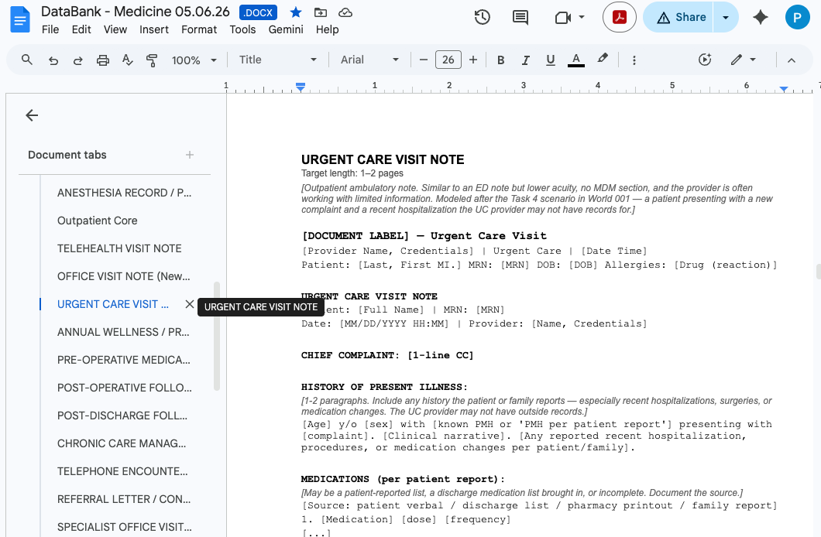

When you decide the types of world-level files that are needed to create your world, simply download them from the DataBank and upload them into the “Synthetic File Templates Folder” in your main World Drive Folder. Of course, you may modify each template as you see fit.

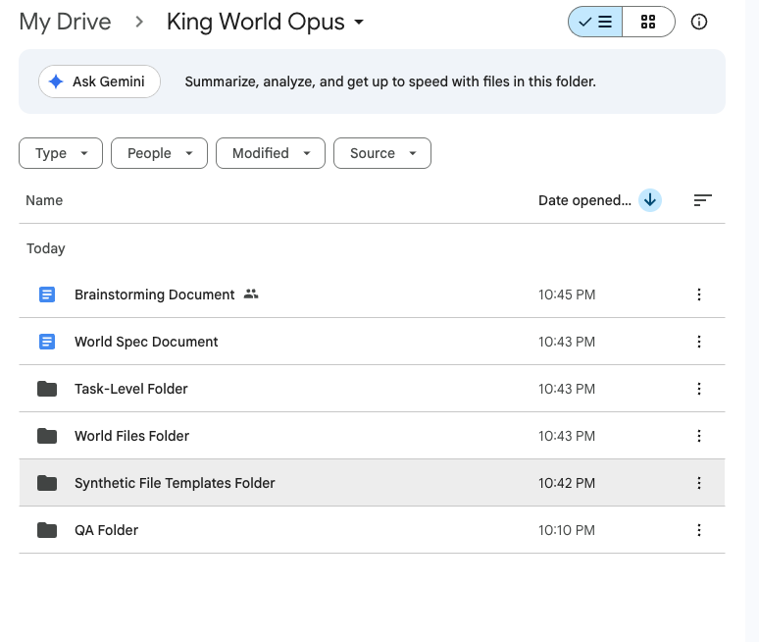

When filling out the tables in your World Spec, under the 'Reference File Origin' column
type the exact filename of the corresponding template in your Reference Templates folder.

See the Writer Guide for the canonical formatting (DataBank filenames, paired templates joined by a plus sign, Public Domain or Custom made annotations).

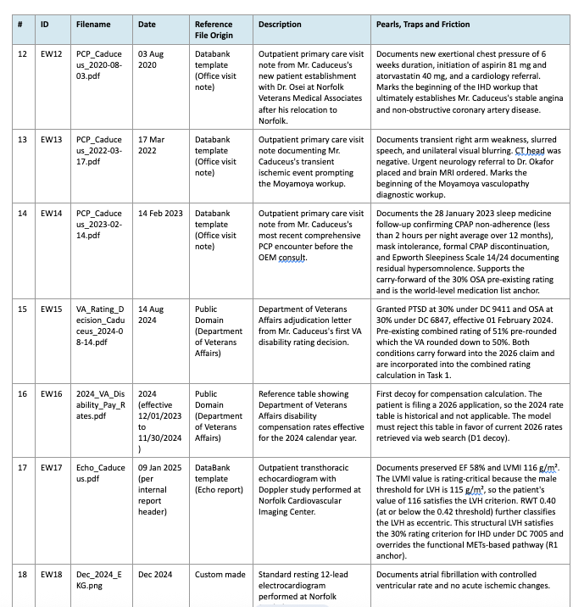

Below are examples of text-based files generated by our writers and engineering team (e.g. from Databank template, public domain, and custom made).

a

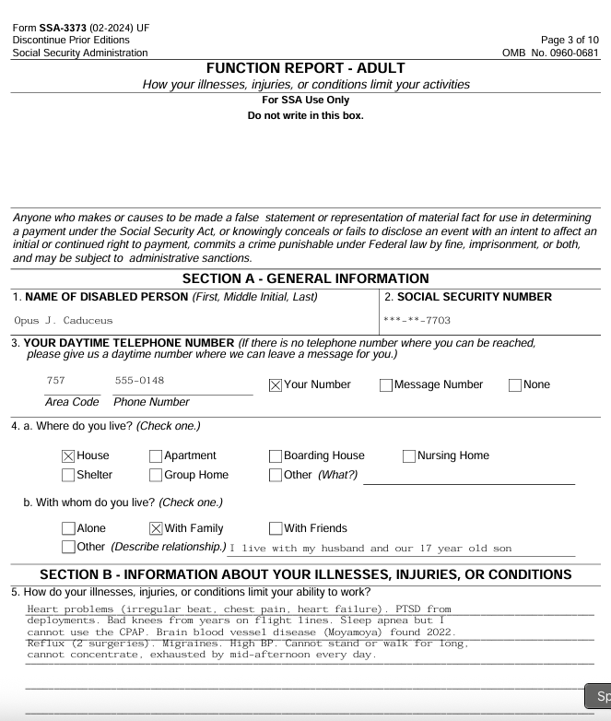

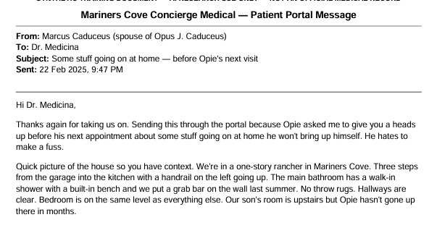

📷 Image-based files
If you want to generate a photo using NanoBanana Pro or ChatGPT, you may feel free to do so. However, ensure that you are generating high-fidelity images —this may require feeding the model a comprehensive vetted prompt prior to image generation.

Below are examples of Ai-generated images from World 004.

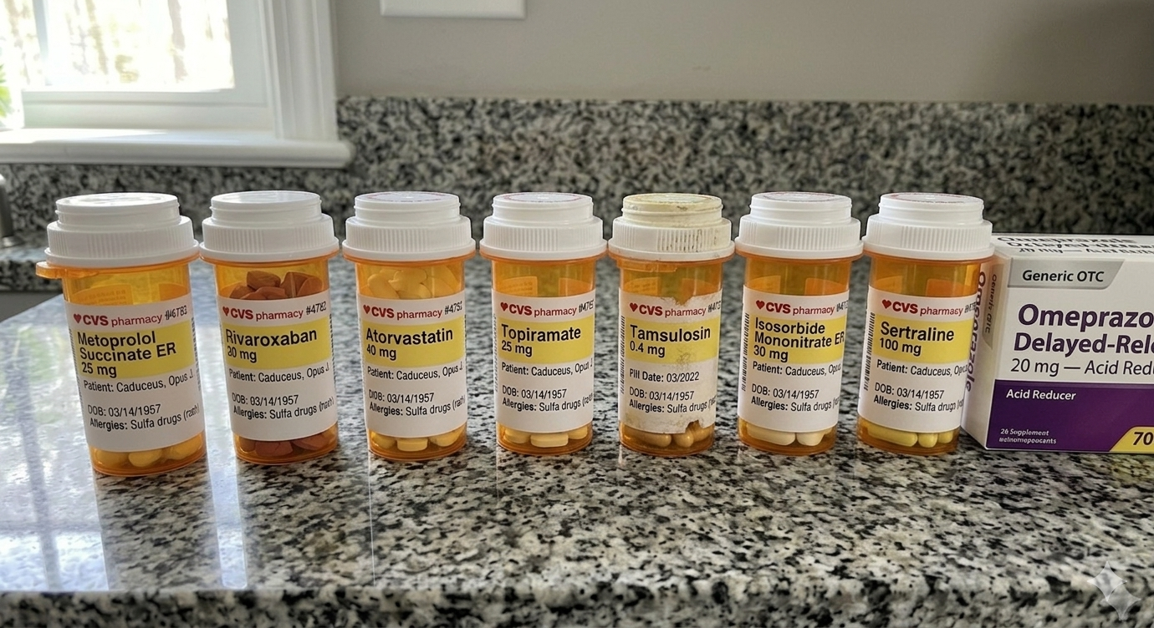

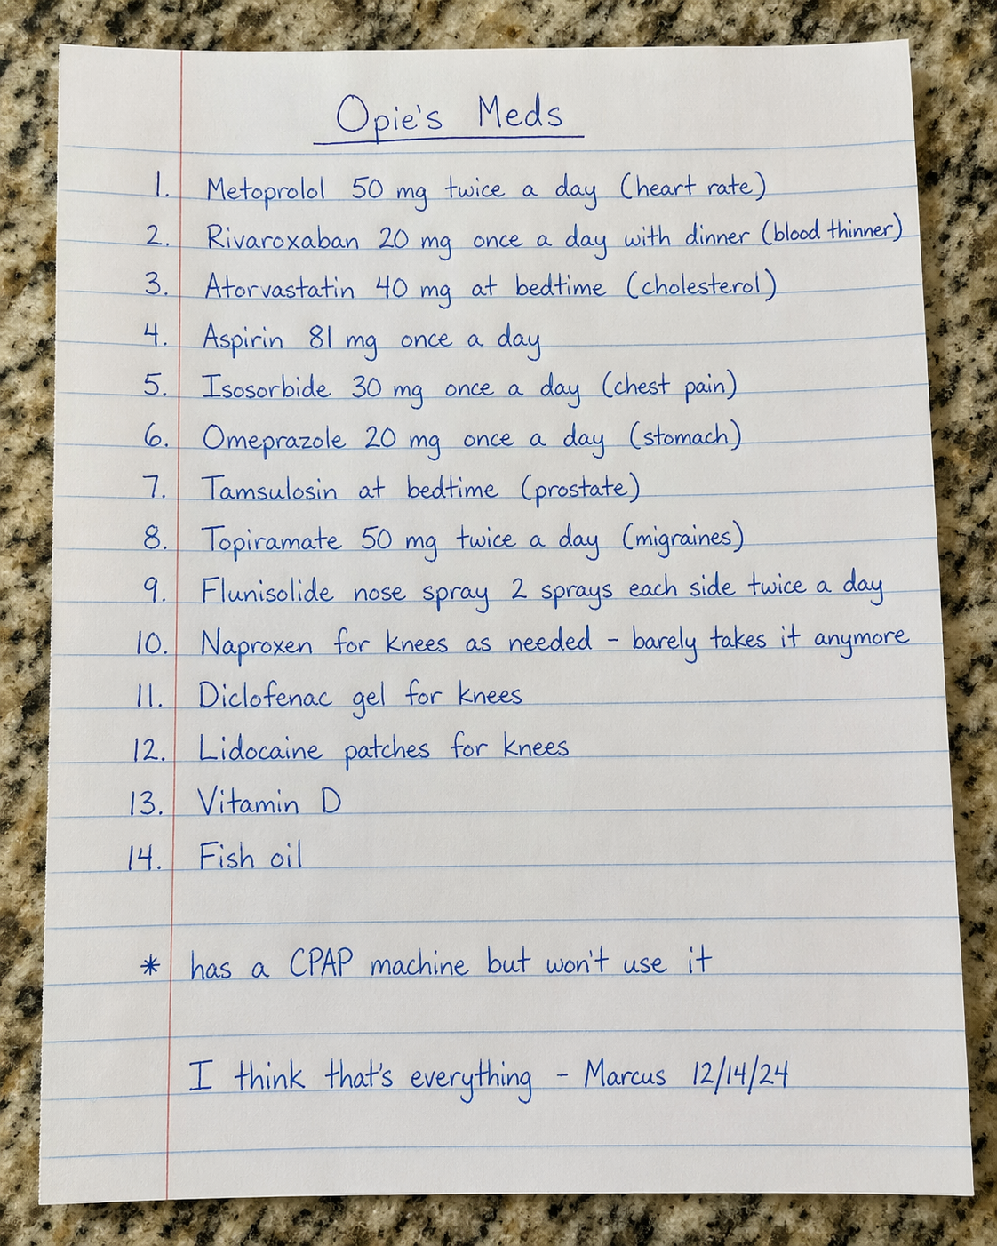

🌐 Public Domain Files
While public-domain images are permitted, please ensure all embedded metadata is scrubbed prior to submission. A simple method is to capture a screenshot of the asset (using Snipping Tool or Cmd+Shift+4) and utilize that version. To maintain compliance, avoid copying and pasting directly from web sources.

We recommend sourcing images from reputable medical or educational repositories. This includes governmental and academic bodies (e.g., NIH, CDC, WHO) or established open-access platforms like Life in the Fast Lane (LITFL) and Radiopaedia, provided the specific file is licensed for reuse.

Assets must be verified for reuse (e.g., public domain or Creative Commons). To ensure high-fidelity compliance, verify the licensing terms on the source site—specifically searching for labels such as “public domain” or “CC BY-SA.” If the licensing status is ambiguous, please refrain from using the image.

When in doubt, err on the side of caution and select an alternative source.

Examples of public domain images used in accepted worlds:
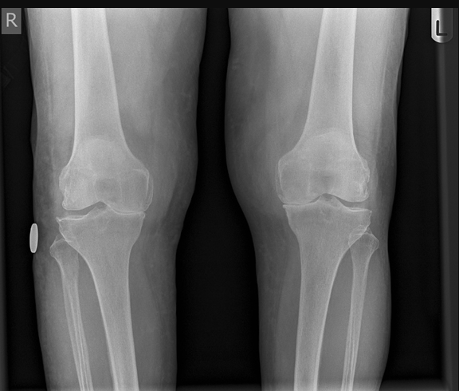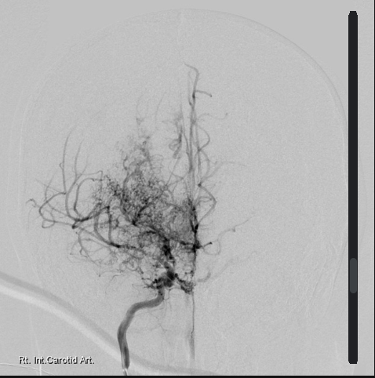

🧬 Stage 3e: Synthetic Clinical Data Generators

How to Use Our Custom Clinical Data Generators

To help you create high-fidelity clinical data without using real patient information, we have developed and curated a set of custom synthetic data generators. These browser-based tools allow you to generate publication-quality mock clinical documents and waveforms for your world file sets.

Tool | What It Generates | Use Case | Link
EEG Simulator | Synthetic EEG tracings with configurable montages, waveforms, and abnormalities | Neuro, epilepsy, ICU, and status epilepticus scenarios | EEG Teaching Sim
EKG Simulator | 12-lead EKG tracings with configurable rhythms, intervals, and pathology | Cardiology, ED, pre-op, and inpatient scenarios | EKG Simulator
EFM Simulator | Electronic fetal monitoring strips with configurable patterns and decelerations | OB/GYN, L&D triage, and intrapartum monitoring scenarios | EFM Simulator (OB/GYN)
Ventilator Simulator (Option 1) | Ventilator waveform displays with configurable modes and parameters | ICU, pulmonary, respiratory failure, and ventilator management scenarios | RT Maven Vent Sim
Ventilator Simulator (Option 2) | Alternative ventilator parameter and waveform generator | ICU, pulmonary, and weaning protocol scenarios | MedData Vent Sim
Lab Report Simulator | Formatted laboratory reports with configurable values, reference ranges, and panels | Any scenario requiring realistic lab documentation | MedData Lab Sim
Radiology Report Simulator | Structured radiology reports with configurable findings, impressions, and recommendations | Any scenario requiring imaging reports (CT, MRI, X-ray, Ultrasound) | MedData Radiology Sim
Sample Lab Reports (Reference) | Real-world lab report formatting and reference ranges from LabCorp’s test menu | Reference for formatting and normal ranges when building custom lab files | LabCorp Test Menu

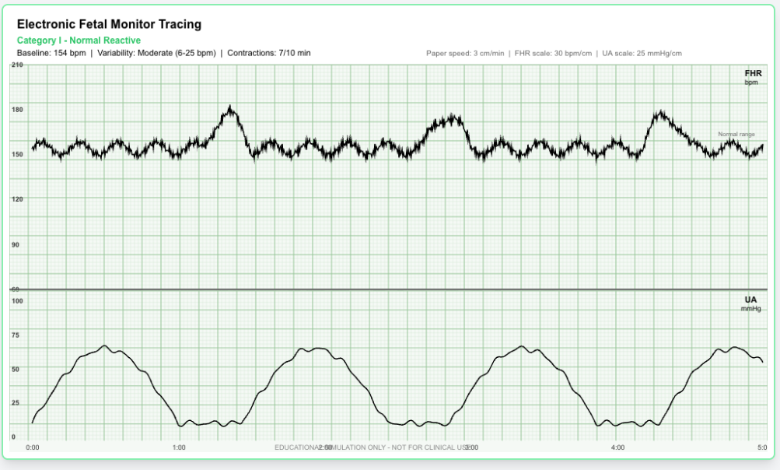

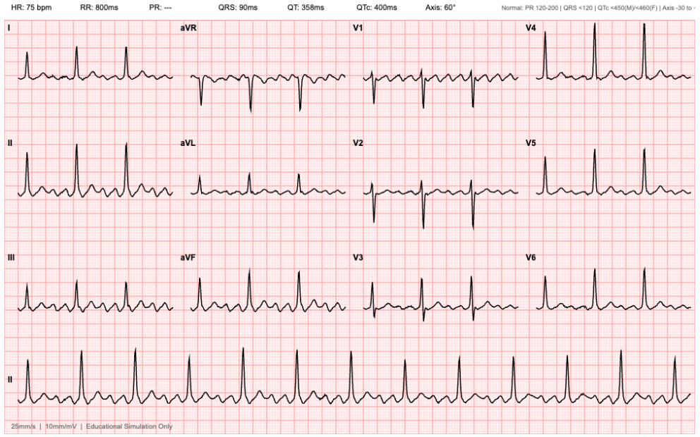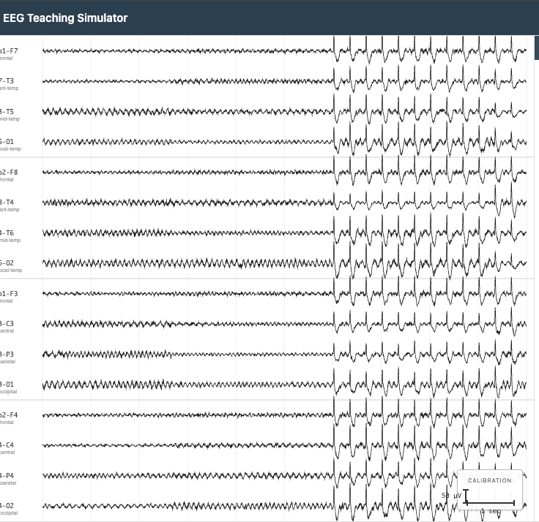

How to Use the Generators in Your Workflow
- Identify the clinical data needed. Review your World Spec and task prompts. What documents would realistically exist at each task’s timepoint?
- Configure the simulator. Open the appropriate tool and set parameters to match your patient’s clinical scenario.
- Export and annotate. Export the generated file. Add a text-based interpretation or report that accompanies the visual data.
- Embed traps in the data. Clinical data files are prime trap locations (e.g., a borderline prolonged QTc when the patient is about to start a QT-prolonging medication).
- Obtain approval for specialized files. Confirm with your team lead before including specialized waveform or imaging files.

Tool Use: Clinical Calculators & Real-Time Search
Some tasks should test whether the AI agent can appropriately use external tools as part of its clinical reasoning. Examples:
- Clinical risk calculators: A task requiring the agent to calculate a HEART score using data scattered across multiple documents.
- Drug interaction checks: A medication list with a subtle but clinically significant interaction the agent should flag unprompted.
- Real-time web search: A task where the correct answer depends on current clinical guidelines that differ from older guidelines embedded in the chart.
- Literature retrieval: A task requiring the agent to cite a specific clinical trial or guideline to justify a treatment recommendation.

Design principle: Tool use should never be the entire task — it should be one component of a larger clinical workflow. The agent should recognize when a tool is needed, use it correctly, and integrate the result into its clinical reasoning.

Only files and images available in the public domain are permitted for use. Please ensure all materials are free of copyright restrictions before using them.

👣 Stage 4: Additional References (Optional)

Stage 4: Additional References (Optional)
This section is for any supporting material your world needs that doesn't fit in Sections 1–3. Not every world will require all of these — include only what is necessary for file builders and task designers to maintain consistency.

Common additions
Key Facts Reference Sheet
A standalone consistency-checking document for file builders. Include every fixed fact that must remain consistent across all files: patient demographics, care team names and credentials, baseline lab values, key dates, medication timeline, and clinical milestones. A fact is "key" if changing it would break a task, neutralize a trap, or create an internal inconsistency. Cross-reference your key facts against your trap designs to make sure the facts each trap depends on are locked in here and not left to builder discretion.
Embedded Conflicts
A log of every deliberate contradiction you have designed into the world: which documents conflict, what each says, and which version is correct. This serves two purposes: it gives file builders explicit instructions on what contradictions to preserve (not "fix"), and it gives you a master list to audit against when reviewing generated files. If a file builder encounters a contradiction not on this list, it's a bug. If it's on this list, it's intentional.
Daily Clinical Reference
Vital signs, laboratory values, and key clinical events for each hospital day. This is the source of truth for per-day clinical data when generating progress notes, nursing notes, and consultant notes. If your world has a multi-day hospitalization, this table prevents drift between what different files say happened on the same day.
Key Laboratory Trends
Longitudinal lab values at key timepoints across the hospitalization. Use this when your traps depend on the agent correctly interpreting lab trends (e.g., a creatinine that rises from 1.2 to 3.8 and then partially recovers, affecting medication dosing decisions at different timepoints).
Specialist Friction
A structured record of where specialist assessments diverge, what each service recommends, and how the attending resolves the disagreement. Use this when your world includes specialist friction traps so that file builders know exactly which recommendations to put in which consult notes.
Clinical Documentation Style Guide (World Spec Template)
Voice and formatting rules for each document type in your world (attending notes, ED notes, consult notes, nursing notes, lab reports, imaging, orders, policies). Use this when your world requires a consistent house style across documents — particularly useful if multiple file builders will work on the same world.
Other world-specific reference tables as needed.
If your world has unique reference needs (e.g., a medication conversion table, an insurance formulary, a facility-specific policy), add them as doc subsections.
Relationship to Section 1
Several of the optional subsections you may have added in Section 1 (Home Medication List, Hidden Clinical Finding, Specialist Friction, Key Laboratory Trends, Embedded Conflicts, Timeline) overlap with or cross-reference the tabs listed here. The Section 1 subsections provide the narrative context — what the clinical situation is and why it matters. The Section 4 / OTHER REFERENCES tabs provide the structured data — the specific values and facts that file builders need to implement your design.

👣 Stage 5: QA Your World Spec

Self-QA/QC Triage (Pre-RL Studio)
Description: This is the QA workflow BEFORE your world-level materials are uploaded to RL Studio. The purpose is to spot check the quality of your deliverables prior to moving on to the next step. At this particular stage, we will focus on the QA/QC of your World Spec document

Step 1: Start a new chat on your Claude Project



Step 2: Copy/paste the following prompt

“Please use the QC checklist I uploaded to review my [World Spec Document]. Walk through every check, give a verdict on each, and flag the Blockers first, then the Majors, then the Minors.”

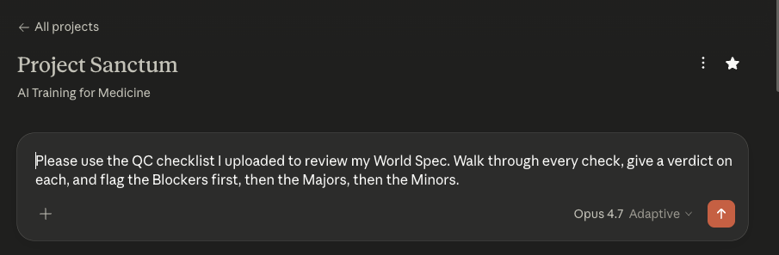
The deliverables that you may QC throughout the production pipeline include the following:
- Brainstorm document
- World Spec document
- World Spec Files (all of them should be QC’d in tandem)
- Task Prompts*
- Golden Response*
- Grader Guidelines*

⚠️NOTE: Remember that the *task prompts, *golden responses, and *grader guidelines have to be written by YOU and not the LLM. You may run a QC after you have written them but you may not ask Claude to write them for you from scratch.

Step 3: Attach your deliverable + the corresponding AutoQC file/s

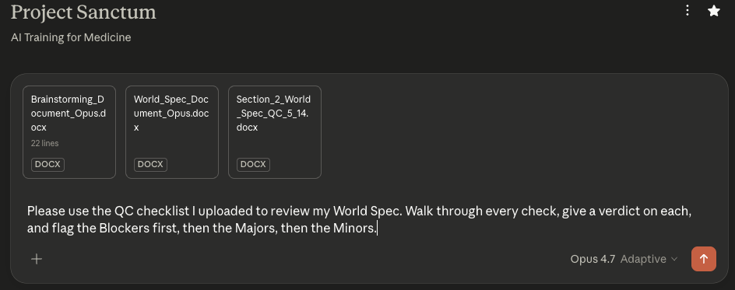

Your Deliverable | Corresponding AutoQC Prompt File/s  +  Supplemental documents
Brainstorm document | AutoQC Prompt: Section 1 Brainstorm.docx
World Spec document | AutoQC_Section_2_World_Spec_v6.2_writer.docx  +  Your Brainstorm document  +  Your templates/reference files
World-level files  (all of them in a zipped folder) | AutoQC Prompt: Section 3 World Files.docx  +  Your World Spec document
Task prompts  (compile in 1 document/pdf) | AutoQC Prompt: Section 4 Task Prompts.docx  +  Your World Spec document  +  Your world-level files (in a zipped folder)
Golden responses  (compile in 1 document/pdf) | AutoQC Prompt: Section 5 Golden Response.docx  +  Your World Spec document  +  Your world-level files (in a zipped folder)  +  Your task prompts  +  Your task-level files
Grader guidelines  (compile in 1 document/pdf) | AutoQC Prompt: Section 6 Grader Guidelines.docx  +  Your World Spec document  +  Your world-level files (in a zipped folder)  +  Your task prompts  +  Your task-level files  +  Your golden responses

😮 Common Mistakes

Common Mistakes in World Spec Docs

Mistake | Why It’s a Problem
Letting blueprint content leak into the prompt | Of the six task fields in Section 2, only the Draft Prompt becomes the user message the agent receives. Workflow, Expected Output, Failure Design, and the file ID list are spec metadata for reviewers, graders, and engineering. The prompt should sound like a real user request, not hand the agent context (workflow labels, output structure, trap hints, "note: some documents may be outdated") that it should derive from the files. Spoon-feeding the model lowers the failure rate signal.
Leaving required sections incomplete | Sections 1.1–1.4, Section 2 (overview paragraph), and Section 3 must all be filled. For optional subsections (1.x, Section 4), omit them entirely if they don't apply — do not leave placeholder text.
Designing files before tasks | Files exist to support tasks. Finish all task designs first, then ask: what files does each task require?
Writing prompts that hint at the trap | The prompt should sound like a real clinical request. "Check for errors in the medication list" gives it away. The agent should discover problems by reading the documents carefully.
Leaving the hidden finding vague | "The case is complex" is not a finding. State exactly what the agent must discover, which files contain the evidence, and what synthesis is required.
Putting trap content in supplementary files | Supplementary files add realism and noise only. If a file contains trap content or information critical to a task, it belongs in Essential.
Including over-authorative summaries | If a single document synthesizes everything the agent needs — a complete discharge summary, a prior clinical summary — make it outdated, incomplete, or wrong in a material respect. Otherwise the agent can answer correctly without cross-referencing, and the task loses benchmarking value.
Not specifying reference documents for essential files | Every essential file should include either a reference file link or a description detailed enough for a non-clinician builder to produce a realistic draft.
A single file resolves a task | If one essential file contains everything the agent needs for a task, no cross-document reasoning is required. Every task should require synthesis across at least two files.

